Scientific Department "Physics, Erosion, Soil Biota"
VESELINKA KALINOVA PETROVA
ECOLOGICAL ASPECTS OF LUPINE CULTIVATION ON ALLUVIAL-MEADOW SOIL
ABSTRACT
Dissertation submitted for the award of the
Educational and scientific degree of Doctor (Ph.D.)
Professional field: Crop Science
Scientific specialty: Soil Science
Supervisor: Assoc. Prof. Hristo Ivailov Valchovski, Ph.D.
Reviewers: Assoc. Prof. Boyka Malcheva, Ph.D.
Assoc. Prof. Gergana Kuncheva, Ph.D.
Sofia, 2026
The dissertation thesis consists of 141 pages, including 26 tables and 19 figures. The list of references includes 130 sources (12 in Cyrillic and 118 in Latin script).
The dissertation thesis was discussed and recommended for defense by an expanded Scientific Council of the "Physics, Erosion, Soil Biota" Department at the "N. Poushkarov" Institute of Soil Science, Agrotechnology and Plant Protection, Sofia.
Supervisor:
Assoc. Prof. Hristo Ivailov Valchovski, Ph.D.
Reviewers:
Assoc. Prof. Boyka Malcheva, Ph.D.
Assoc. Prof. Gergana Kuncheva, Ph.D.
The defense materials are available on the website of the Agricultural Academy – www.agriacad.bg and on the website of the “N. Poushkarov” Institute of Soil Science, Agrotechnology and Plant Protection – www.iss-poushkarov.org

1. INTRODUCTION
Under current intensive methods of mineral fertilization, soil contamination can reach critical levels. This necessitates a strong focus on this issue, which has an adverse impact on public health. Another negative consequence is the reduction of soil pH. Furthermore, groundwater is contaminated with nitrates and other harmful substances, and heavy rainfall leads to the pollution of rivers, lakes, and drinking water.
The utilization of symbiotic nitrogen fixation represents a fundamental method for achieving sustainable organic agriculture. Legume crops, in symbiosis with nodule bacteria, constitute the most effective nitrogen-fixing systems, increasing biologically fixed nitrogen both in plant produce and in the soil. Microbial inoculations play a key role in reducing the use of mineral fertilizers. In Bulgaria, the nitrogen-fixing systems of a large number of legume, cereal, and forage crops have been studied, but the potential of lupine regarding its responsiveness to inoculation with host-specific nodule bacteria of the genus Bradyrhizobium sp. (Lupinus) and the nitrogen-fixing activity of these symbiotic systems remains insufficiently explored. In this context, evaluating the potential of lupine for inoculation with nitrogen-fixing bacteria of the genus Bradyrhizobium and in combination with bacteria of the genus Azospirillum forms the core objective of this dissertation research. As an important crop, lupine offers a wide range of applications, including green manure and forage in organic farming, as well as a product for the food industry. Europe is characterized by a diversity of species, with sweet varieties of annual species—white, yellow, and blue lupine—being the most widely cultivated. The most prominent and widely used species is sweet white lupine (Lupinus albus saccharatus L.), which features high protein content (32–38%) and high yields comparable to other forage legumes. Lupine enriches the soil with nitrogen and organic matter, improves soil structure, and protects against wind erosion thanks to its deep-penetrating root system. This makes it a valuable crop with high-quality characteristics. Lupine seeds contain proteins and fats characterized by high digestibility and low levels of phytic acid, protease inhibitors, and lectins. With these characteristics, lupine offers a promising alternative crop option.

2. AIM OF THE DISSERTATION
The study aims to evaluate the effect of single inoculation with bacteria of the genus Bradyrhizobium and dual inoculation with bacteria of the genus Bradyrhizobium and the genus Azospirillum on the quality of sweet white lupine yield, soil microflora activity, and the residual effect on the yield and quality of a subsequent cereal crop (triticale).
TO ACHIEVE THE STATED AIM, IT IS NECESSARY TO SOLVE THE FOLLOWING OBJECTIVES:
- To examine the effect of single and dual inoculation of lupine with bacteria of the genus Bradyrhizobium and an Azospirillum strain on plant yield and product quality.
- To evaluate the nitrogen-fixing potential and virulence of the tested bacterial strains of the genus Bradyrhizobium.
- To select effective and genetically compatible combinations of lupine and strains of Bradyrhizobium spp. and Azospirillum sp., with and without organic fertilizer application, and evaluate their performance under field conditions to enhance crop yield and quality.
- To investigate, under pot experiment conditions on Alluvial-Meadow soil, the residual effect of sweet white lupine cultivation and applied treatments on the yield and quality of triticale.
- To determine the optimal combinations of treatments applied during lupine cultivation that enhance subsequent cereal crop yield and quality.
- To test the effect of single and dual inoculation of lupine with bacteria of the genera Bradyrhizobium and Azospirillum on soil microflora.

3. OBJECT, MATERIALS, AND METHODS

3.1. Object of the Study
To achieve the aim and planned objectives, two pot experiments and three field experiments were conducted in the village of Tsalapitsa on Alluvial-Meadow soil. These experiments aimed to investigate the effect of inoculating lupine with nitrogen-fixing symbiotic and associative bacteria, as well as the residual effect of the applied treatments on triticale.

3.1.1. Soil
The characteristics of the studied Alluvial-Meadow soil (Tsalapitsa village) are presented in Table 1 and Table 2. The soil has a neutral to slightly acidic reaction, low humus content, low availability of mobile nitrogen and phosphorus, and good availability of potassium. By particle size distribution, it is light sandy loam—24.08% physical clay, with a predominant coarse sand fraction (particle size 2–0.2 mm) . Total and active forms of CaCO₃ are absent in the topsoil. The soil has low hygroscopic moisture.
Table 1. Agrochemical characteristics of the studied Alluvial-Meadow soil at a sampling depth of 0 to 30 cm
Total nitrogen, % | Total phosphorus, % | Mobile nitrogen mg/1000 g | Mobile phosphorus mg/1000 g | Mobile potassium mg/1000 g | Humus %
0.049 | 0.070 | 7.6 | 8.4 | 25.6 | 1.71
Table 2. Particle size distribution of Alluvial-Meadow soil (Tsalapitsa village)
Depth cm | Hygroscopic moisture % | Particle size in mm - % |  |  |  | Physical clay <0.01%
 |  | 2–0.2 | 0.2–0.02 | 0.02–0.002 | <0.002
0–30 | 2.04 | 45.40 | 23.2 | 11.3 | 13.1 | 24.08

3.1.2. Soil Meliorants
Farmyard manure was applied in an amount equivalent to 4 t/da. It is characterized by a high content of total carbon (10.58%), mineral nitrogen (633.6 mg/kg), available P 61.5 mg P₂O₅/100 g), potassium (143.9 mg K₂O/100 g), and a slightly alkaline soil reaction – pH 7.5 (H₂O). For the pot experiment with lupine, mineral nutrients were supplied according to Hoagland D.R. (1920). In the field experiments with lupine, nitrogen, phosphorus, and potassium fertilizers were applied prior to sowing at rates of N₄P₈K₈ kg active ingredient/da to the respective treatment variants.

3.1.3. Crop Species
- Sweet white lupine (Lupinus albus saccharatus L.) cultivar 'Laki' – a spring cultivar with light beige seed color, provided by the "K. Malkov" Institute of Plant Genetic Resources, Sadovo.
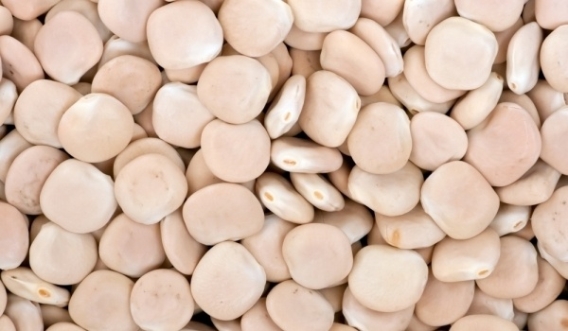
Photo 1. Seeds of sweet white lupine
- Triticale (Tritico secale) cultivar 'Vihren' – a medium-early, drought-tolerant cultivar.
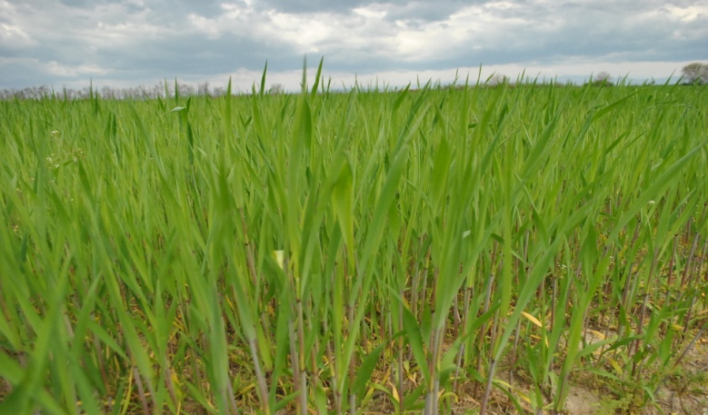
Photo 2. Triticale field experiment
Triticale is also successfully cultivated on acidic, low-productivity soils in the plain, sub-mountainous, and mountainous regions of the country.

Bacterial Cultures
For single and dual inoculation, seven strains of Bradyrhizobium sp. (Lupinus) (295, 296, 297, 298, 299, 300, and 301) were studied. These are symbiotic nitrogen fixers belonging to the genus Bradyrhizobium, family Rhizobiaceae, along with the associative nitrogen fixer Azospirillum brasilense sp. 107 from the collection of nitrogen-fixing bacteria at the Soil Microbiology Laboratory, "N. Poushkarov" ISSAP.

3.2. Methods
The numbers of major taxonomic and physiological groups of microorganisms were determined using the ten-fold dilution method, with soil suspensions plated on selective agar media according to Grudeva et al. (2007). Microorganism counts are presented as colony-forming units (CFU) per 1 g of oven-dry soil.
The abundance of the following physiological and taxonomic groups of soil microorganisms was determined:
- Ammonifying microorganisms: via incubation of soil suspensions on Nutrient Agar (MPA) for a period of three days.
- Spore-forming microorganisms: via incubation of soil suspensions on Nutrient Agar (MPA) following pasteurization at 80 °C for 10 minutes, followed by three days of incubation.
- Microscopic fungi: on acidified Chapek Dox medium after seven days of incubation.
- Actinomycetes and mineral-nitrogen-utilizing bacteria: via incubation of soil suspensions on Starch-Ammonia Agar after seven days of incubation.
- Cellulose-decomposing microorganisms: determined on solid Hutchinson culture medium after seven days of incubation.
- Oligotrophic microorganisms: on Mishustin medium after seven days of incubation.
- Diazotrophs: on Ashby medium after seven days of incubation.

3.2.1. Chemical and Biochemical Analyses
- Nitrogenase activity: determined by the acetylene reduction assay (Hardy et al., 1973) on the detached root system during the flowering stage of lupine.
- Determination of macro- and microelements in plant biomass: the method of Milka Mincheva and Anna Brashnarova was applied, which involves dry mineralization of plant samples.
- Total soil biological activity (CO₂ evolution): determined using a titrimetric method according to Alef K. and P. Nannipieri (1998). Results are expressed as mg CO₂ / 100 g oven-dry soil / 1 h.
- Microbial biomass carbon: determined according to the method of Anderson and Domsch (1978), with results expressed as mg C / 100 g oven-dry soil.
- Total nitrogen, P, K, and Ca: Total nitrogen was determined by the Kjeldahl method (1883) using wet digestion; Phosphorus (P) by the vanadate-molybdate method; and Potassium (K) and Calcium (Ca) by flame photometry.
- Bioelement metals: determined by atomic absorption spectrometry following dry ashing in 20% HCl.
Various chemical, agrochemical, and physical methods were used to determine fundamental soil properties:
- Particle size distribution: determined by the Kachinsky method (1970).
- Organic matter content: evaluated by the Tyurin method (1937).
- Hydrolyzable nitrogen: determined by the Bremner method (1965).
- Available forms of phosphorus and potassium: determined by the Ivanov method (1984).
- Soil reaction (pH): measured potentiometrically in water and potassium chloride solution.

3.3. Pot Experiments

3.3.1. Pot Experiment with Lupine
In a pot experiment, the influence of single and dual inoculation of Lupinus albus saccharatus L. with a Bradyrhizobium sp. (Lupinus) strain against a background of farmyard manure fertilization was investigated regarding yield, nitrogen-fixing activity, nodulation, and total nitrogen content in plant biomass. The experiment was conducted in the greenhouse of the "N. Poushkarov" ISSAP in 5-liter capacity pots. It included 21 variants in 4 replicates, featuring 7 strains of Bradyrhizobium spp. in combination with mineral fertilizer, farmyard manure, and Azospirillum sp. strain 107 at 60% soil water holding capacity (WHC).
Seeds of the tested crop (Lupinus albus saccharatus L.) were surface-sterilized with 95% ethanol for 10 seconds, followed by sterilization with hydrogen peroxide for 3–4 minutes, thoroughly rinsed multiple times with sterile water, and dried. Seven bacterial strains—Bradyrhizobium spp. (Lupinus) 295, 296, 297, 298, 299, 300, and 301 from the collection of "N. Poushkarov" ISSAP and Az. brasilense 107—were used as inoculants, applied in the form of suspensions with titers of 10⁹ and 10⁸ cells/ml, respectively.
Table 3. Experimental layout of the treatment variants in the pot experiment
Variant No. | Treatment Description
1. | Control – uninoculated seeds, no fertilizer application to the soil
2. | Inoculation with Bradyrhizobium sp. strain 295 (Lupinus)
3. | Inoculation with Bradyrhizobium sp. strain 296 (Lupinus)
4. | Inoculation with Bradyrhizobium sp. strain 297 (Lupinus)
5. | Inoculation with Bradyrhizobium sp. strain 298 (Lupinus)
6. | Inoculation with Bradyrhizobium sp. strain 299 (Lupinus)
7. | Inoculation with Bradyrhizobium sp. strain 300 (Lupinus)
8. | Inoculation with Bradyrhizobium sp. strain 301 (Lupinus)
9. | Inoculation with Bradyrhizobium sp. strain 295 (Lupinus) + farmyard manure (200 g/pot)
10. | Inoculation with Bradyrhizobium sp. strain 296 (Lupinus) + farmyard manure (200 g/pot)
11. | Inoculation with Bradyrhizobium sp. strain 297 (Lupinus) + farmyard manure (200 g/pot)
12. | Inoculation with Bradyrhizobium sp. strain 298 (Lupinus) + farmyard manure (200 g/pot)
13. | Inoculation with Bradyrhizobium sp. strain 299 (Lupinus) + farmyard manure (200 g/pot)
14. | Inoculation with Bradyrhizobium sp. strain 300 (Lupinus) + farmyard manure (200 g/pot)
15. | Inoculation with Bradyrhizobium sp. strain 301 (Lupinus) + farmyard manure (200 g/pot)
16. | Inoculation with Bradyrhizobium sp. strain 299 (Lupinus) + Azospirillum sp. 107
17. | Inoculation with Bradyrhizobium sp. strain 300 (Lupinus) + Azospirillum sp. 107
18. | Inoculation with Bradyrhizobium sp. strain 299 (Lupinus) + Azospirillum sp. 107 + farmyard manure (200 g/pot)
19. | Inoculation with Bradyrhizobium sp. strain 300 (Lupinus) + Azospirillum sp. 107 + farmyard manure (200 g/pot)
20. | Farmyard manure (200 g/pot)
21. | Mineral nutrients (210 ppm)
At the flowering phenophase of the plants, root samples of lupine were taken to determine the virulence of the tested nodule bacterial strains by recording the number of nodules. Plant height growth was monitored during the phenophases of 2nd–3rd leaf, flower bud formation, 4th–5th leaf, 9th–10th leaf, flowering, pod formation, and grain filling. After harvesting the experiment, soil samples were taken to determine the abundance and development of soil microorganisms, conduct agrochemical analyses, and determine total biological activity and microbial biomass carbon. Biometric plant parameters were also recorded after drying. Total nitrogen content in the plant parts of lupine was determined.

3.3.2. Pot Experiment with Triticale
The residual effect of the applied lupine inoculations, along with organic and mineral fertilization, on the yield and quality of the cereal crop triticale was evaluated. The experiment was established in the same pots where lupine had been grown as a preceding crop. Following the harvest of the triticale experiment, soil and plant samples were collected to perform microbiological, biochemical, agrochemical, and physical analyses.

3.4. Field Experiments

3.4.1. Field Experiments with Lupine
The field experiment with lupine was set up on harvest plots measuring 10 m², with a spacing of 0.50 m between plots and 0.70 m between replicates, at a seeding rate of 10 kg/da.
Nitrogen, phosphorus, and potassium fertilizers were applied as N₄P₈K₈ kg active ingredient/da to the respective treatment variants prior to sowing.
The experiments were established during the second half of April, and the crop was harvested at the end of August. Soil samples for microbiological analysis were taken from a soil depth of 0--20 cm.
After harvesting at full maturity, soil samples were collected to determine soil microorganism counts, agrochemical properties, total soil biological activity, and microbial biomass carbon. Plant biometric data were also recorded, and total nitrogen in the plant parts of lupine was determined.
Field Experiment Layout with Lupine:
- Control – uninoculated seeds, no fertilizer application to the soil
- Inoculation with Bradyrhizobium sp. strain 300
- Inoculation with Bradyrhizobium sp. strain 300 + farmyard manure
- Inoculation with Bradyrhizobium sp. strain 300 + Azospirillum sp. 107
- Inoculation with Bradyrhizobium sp. strain 300 + Azospirillum sp. 107 + farmyard manure
- Farmyard manure (4 t/da)
- Mineral fertilization (4 kg/da active ingredient N and 8 kg/da active ingredient P and K)
The field experiment with lupine was conducted under the following climatic conditions:
During the growing season from April to August inclusive, the sum of mean daily air temperatures was:
- For 2014: 97.3 °C
- For 2015: 105.5 °C
Total precipitation for the same period was:
- For 2014: 392.10 mm
- For 2015: 263.80 mm
From these data, it was established that 2014 was a slightly cooler and wetter year compared to 2015, which exhibited higher cumulative mean daily temperatures and lower rainfall than the preceding year.
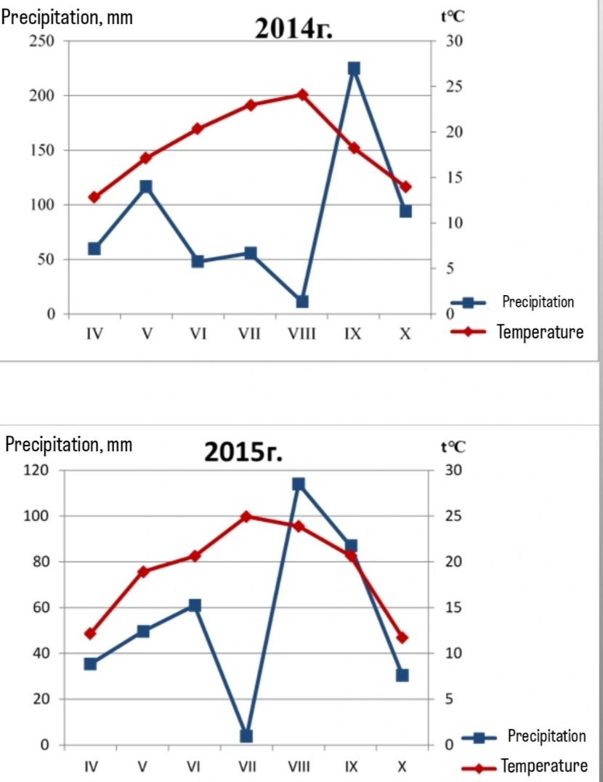
Figure 1. Climatogram

3.4.2. Field Experiment with Triticale
The residual effect of the inoculations applied to the preceding crop, as well as organic and mineral fertilizer application, on the yield and quality of the cereal crop triticale was evaluated under field experiment conditions. The experiment was established in mid-October, and the crop was harvested at full maturity during the first days of July. Soil and plant samples were collected to perform corresponding microbiological, biochemical, agrochemical, and physical analyses.

3.5. Statistical Methods
Data from the pot and field experiments with lupine and triticale were processed using software running under Windows in the Qbase environment using Fortran. Statistical algorithms developed by Sokal for processing small sample sizes were employed.
To determine the statistical significance of differences between the control and the respective treatment variants, analysis of variance (ANOVA) was applied, using the F-test to evaluate test validity and Fisher's Least Significant Difference (LSD) at significance levels of P < 0.05, P < 0.01, or P < 0.001, depending on data variance. According to Duncan's multiple range test, data were separated into groups at a significance level of P < 0.05 (95% confidence level).

4. RESULTS AND DISCUSSION

4.1. Pot Experiment with Lupine

4.1.1. Effect of Inoculation with Nitrogen-Fixing Bacterial Strains and Farmyard Manure on the Investigated Physiological and Taxonomic Groups of Soil Microorganisms in a Pot Experiment with Lupine
In almost all variants, inoculation exerted a markedly favorable complex effect on the parameters of the investigated physiological and taxonomic groups of soil microorganisms in the pot experiment with lupine. All studied parameters were positively affected by the applied treatments, with their increase compared to the respective controls being statistically significant at P<0.05, P<0.01, and P<0.001, depending on data variance.
Data regarding the effect of single and mixed inoculations on the abundance of spore-forming microorganisms showed the highest and statistically significant increase compared to the control in the variant with dual inoculation with Bradyrhizobium sp. strain 299 (Lupinus) + Azospirillum sp. 107 at a significance level of P<0.001, followed by the variant inoculated with Bradyrhizobium sp. strain 300 (Lupinus) + farmyard manure at P<0.01. A similar effect was observed in the mineral fertilization variant. The increase in spore-forming bacteria is characteristic of fertilized soils and serves as an indicator of soil cultivation/improvement.
Regarding the total count of ammonifying microorganisms, an increase in their numbers was observed with a proven difference at P<0.001. The highest value was recorded in the variant inoculated with Bradyrhizobium sp. strain 299 (Lupinus), followed by inoculation with Bradyrhizobium sp. strain 300 (Lupinus) + farmyard manure at P<0.001 (). The increase in ammonifying microorganisms is associated with an increased rate of organic matter decomposition in the soil.
For diazotrophs, a significant increase in their communities compared to the control was observed in almost all variants at P<0.001, except for the variants with Bradyrhizobium sp. strain 301 (Lupinus) + farmyard manure and mineral fertilization, where the differences were not statistically significant. Inoculation with Bradyrhizobium sp. strain 300 (Lupinus) combined with farmyard manure application had a significant impact, showing a substantial increase in microbial abundance relative to the control (1046.34%), followed by inoculation with Bradyrhizobium sp. strain 300 (Lupinus) + Azospirillum sp. 107 + farmyard manure (978.86%) and single inoculation with Bradyrhizobium sp. strain 300 (Lupinus) (919%) (). Diazotrophs are involved in atmospheric nitrogen fixation. Their increased numbers are associated with inoculation with symbiotic and free-living nitrogen-fixing bacteria.
In oligonitrophils, a significant increase in abundance compared to the control was established across all variants at P<0.001, with the exception of Bradyrhizobium sp. strain 297 (Lupinus) + farmyard manure and mineral fertilization, where differences were non-significant. The highest value was found in the variant with Bradyrhizobium sp. strain 296 (Lupinus) + farmyard manure (400%), followed by Bradyrhizobium sp. strain 300 (Lupinus) + farmyard manure (390.47%) (). Oligonitrophils are involved in metabolic processes under soil nutrient deficiency. Their increase is likely due to a lack of certain elements in the soil.
Regarding microorganisms utilizing mineral nitrogen, an increase in values compared to the control was observed in most variants, with the exception of organic and mineral fertilization treatments. The most significant increase occurred in the variant with Bradyrhizobium sp. strain 295 (Lupinus) + farmyard manure (153.16%), followed by Bradyrhizobium sp. strain 300 (Lupinus) + Azospirillum sp. 107 (146.83%). The lowest values were recorded under organic fertilization, while mineral fertilization resulted in a decrease in values compared to the control, indicating that organic and mineral fertilizers inhibit the development of mineral-nitrogen-utilizing microorganisms (). Bacteria utilizing mineral nitrogen participate in nitrification and nitrogen fixation processes, making their increase in inoculated variants expected.
The influence of the applied treatments on the development of humus-forming microorganisms was most pronounced in the variant with Bradyrhizobium sp. strain 300 (Lupinus) + Azospirillum sp. 107 (375.86%), followed by Bradyrhizobium sp. strain 300 (Lupinus) + farmyard manure (P<0.001, 262%) (). The results demonstrate the positive effect of inoculation and farmyard manure application on soil humus formation.
The development of cellulose-decomposing microorganisms was also influenced by the applied treatments. A statistically proven increase in values compared to the control was observed in most variants, whereas the difference in the mineral fertilization variant was non-significant. The most significant increase in abundance relative to the control occurred in the variant with Bradyrhizobium sp. strain 300 (Lupinus) + Azospirillum sp. 107 (300%), followed by Bradyrhizobium sp. strain 300 (Lupinus) + Azospirillum sp. 107 + farmyard manure, and single inoculation with Bradyrhizobium sp. strain 300 (Lupinus) (). The increased count of cellulose-decomposing microorganisms is associated with the intensive decomposition of plant residues in the soil.
The effect of treatments on the development of microscopic fungi was expressed as an increase, statistically proven across all variants, being most significant in the variant with Bradyrhizobium sp. strain 300 (Lupinus) + Azospirillum sp. 107 (800%), followed by single inoculation with Bradyrhizobium sp. strain 300 (Lupinus) (566%) (). Similar results were reported by other authors (Bashan and Holguin, 1997; German et al., 2000; Tilak et al., 2006), who investigated co-inoculation with Azospirillum and studied the synergistic interactions that support other microorganisms in exerting their beneficial effects. Microscopic fungi are associated with an increased rate of organic matter decomposition and nutrient cycling in the soil.
Conclusion:
Inoculation with Bradyrhizobium sp. strain 300 combined with farmyard manure application significantly affected the development and abundance of the investigated physiological and taxonomic groups in the rhizosphere soil of lupine. For most groups, the positive effect was most pronounced in the variants with single inoculation with Bradyrhizobium sp. strain 300 (Lupinus) and dual inoculation with Bradyrhizobium sp. strain 300 (Lupinus) + Azospirillum sp. 107, both with and without farmyard manure application.

4.1.2. Effect of Applied Treatments on Total Nitrogen Content and Yield in Plant Parts in a Pot Experiment with Lupine
The obtained results clearly demonstrate the effect of the applied biotechnological methods and fertilizers on the tested crop. An increase in grain yield was observed, with exceptions in variants treated with mineral nutrients and single inoculation with Bradyrhizobium lupini sp. strain 296. The highest percentage increase was recorded in the variant with single inoculation with Bradyrhizobium lupini sp. strain 300 (122.2%), followed by dual inoculation with the same strain + Azospirillum sp. 107 + farmyard manure (107.7%). Nearly equivalent values were obtained with dual inoculation in combination with farmyard manure. Similar results were obtained regarding the influence of the above treatments on total nitrogen content in the grain ().
All applied treatments increased the total nitrogen content in the dry weight of vegetative aboveground biomass. Regarding this plant fraction, higher efficiency was exhibited by strains No. 295, 296, 297, and 301 under single inoculation, as well as dual inoculation with No. 300, and in combination with farmyard manure for No. 295, 297, and 300. These results allow for the selection of an effective strain depending on the crop management objective – whether for grain, forage, or green manure.
Data obtained from nitrogenase enzyme activity measurements in the root system of lupine at the flowering stage showed the highest value in the variant with single inoculation with Bradyrhizobium lupini sp. strain 300 (19.09 μM), followed by dual inoculation + farmyard manure (13.73 μM), dual inoculation without farmyard manure (16.50 μM), and single inoculation with the same strain + farmyard manure (9.14 μM C2​H4​). Regarding nodulation, the highest nodule count was recorded in variants inoculated with Bradyrhizobium lupini sp. strain 300, ranging from 80 to 138 nodules per pot.
Conclusion:
The experimental results demonstrate that inoculation with Bradyrhizobium contributes to significant increases in the evaluated parameters of lupine grown on Alluvial-meadow soil. Inoculation with Bradyrhizobium strain 300 can be considered the most efficient inoculant choice for sweet white lupine (Lupinus albus saccharatus L.), as evidenced by the highest grain yield, nodule count, and biological nitrogen fixation.

4.1.3. Effect of Inoculation with Nitrogen-Fixing Bacterial Strains, Farmyard Manure, and Mineral Fertilizer on Plant Parameters of Dry Biomass
Data regarding the effect of single and dual inoculations combined with organic fertilizer application demonstrate that lupine yield is affected to varying degrees by all applied treatments, as well as across different plant parameters including height, weight, and other morphological measurements. Overall, plant growth and development were positively affected compared to the control. The values of the various evaluated parameters increased with statistical significance (P < 0.001) in most treatment variants relative to the control.
Stem height increased most significantly in the variant inoculated with Bradyrhizobium sp. strain 295 + farmyard manure (60.97%, P < 0.001), followed by inoculation with Bradyrhizobium sp. strain 297 (Lupinus) + farmyard manure (39.75%) and inoculation with Bradyrhizobium sp. strain 300 (Lupinus) + farmyard manure (39.75%). This parameter was least affected in the variant inoculated with Bradyrhizobium sp. strain 299 (9.02%) and in the mineral fertilization variant relative to the control, where the difference was not statistically significant . Regarding stem weight, the most substantial statistically significant increase was recorded in the variant inoculated with Bradyrhizobium sp. strain 295 (Lupinus) + farmyard manure, followed by inoculation with Bradyrhizobium sp. strain 300 (Lupinus) + farmyard manure at P < 0.001. In the mineral fertilization variant, the result was not significantly affected at P < 0.05. In all other variants, differences were statistically significant at P < 0.001 . The root system of lupine developed best in the variants inoculated with Bradyrhizobium sp. strains 296, 295 + farmyard manure, 301 + farmyard manure, and 300 (Lupinus) + Azospirillum sp. 107 (100.42%), with statistical significance proven at P < 0.001. In contrast, a decrease in root weight compared to the control was observed in the mineral fertilization variant .
The applied treatments exerted a positive influence by increasing lupine grain weight values across all variants, with the exception of the mineral fertilization variant, where a reduction in weight relative to the control was observed. The highest values were obtained in the variant inoculated with Bradyrhizobium sp. strain 295 (Lupinus) + farmyard manure (197.82%), followed by inoculation with Bradyrhizobium sp. strain 298 (Lupinus) + farmyard manure (160.86%, P < 0.001) .
The effect of inoculation with nitrogen-fixing bacterial strains combined with farmyard manure positively influenced stem growth, aboveground biomass weight, root mass, and grain yield. The mineral fertilization variant showed no stimulating effect, instead suppressing root development and grain weight in lupine.
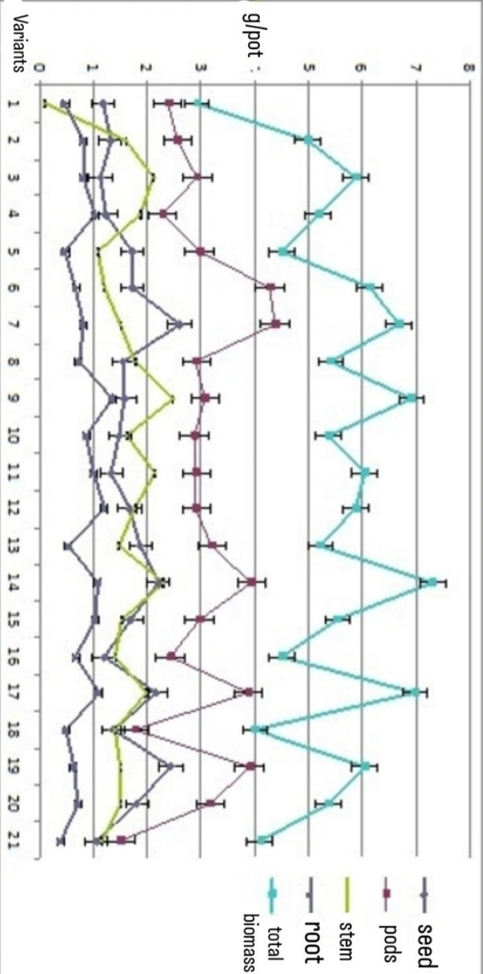
Variants: 1. Control, 2. Bradyrh. sp. 295, 3. Bradyrh. sp. 296, 4. Bradyrh. sp. 297, 5. Bradyrh. sp. 298, 6. Bradyrh. sp. 299, 7. Bradyrh. sp. 300, 8. Bradyrh. sp. 301, 9. Bradyrh. sp. 295 + farmyard manure, 10. Bradyrh. sp. 296 + farmyard manure, 11. Bradyrh. sp. 297 + farmyard manure, 12. Bradyrh. sp. 298 + farmyard manure, 13. Bradyrh. sp. 299 + farmyard manure, 14. Bradyrh. sp. 300 + farmyard manure, 15. Bradyrh. sp. 301 + farmyard manure, 16. Bradyrh. sp. 299 + Azospirillum sp. 107, 17. Bradyrh. sp. 300 (Lupinus) + Azosp. sp. 107, 18. Bradyrh. sp. 299 (Lupinus) + Azosp. sp. 107 + farmyard manure, 19. Bradyrh. sp. 300 + Azosp. sp. 107 + farmyard manure, 20. Farmyard manure, 21. Mineral fertilization.
Figure 2. Effect of applied treatments on Lupinus albus saccharatus L. under pot experiment conditions with Alluvial-meadow soil on dry weight of grain, stem, roots, and total plant biomass in g/pot.

4.2. Pot Experiment with Triticale

4.2.1. Residual Effects of Applied Treatments to Preceding Lupine on the Abundance of Investigated Physiological and Taxonomic Groups of Soil Microorganisms in the Rhizosphere of Triticale (Pot Experiment)
All investigated groups of microorganisms in the rhizosphere soil of triticale responded positively to the treatments applied to the preceding lupine crop, showing statistically significant increases compared to their respective controls at P < 0.05, P < 0.01, and P < 0.001, depending on data variance (2). Similar results were reported by Górski and Płaza (2024), who observed that cultivating lupine leads to improved yields in subsequent triticale crops.
Regarding the abundance of spore-forming microorganisms, the treatments resulted in the largest increase relative to the control in the variant inoculated with Bradyrhizobium sp. strain 300 + farmyard manure (159.28%, P < 0.001). The least significant increase was recorded in the mineral fertilization variant (2). Farmyard manure is exceptionally rich in spore-forming bacteria, and its application naturally increases their population.
An increase in numbers was observed for ammonifying microorganisms, with the exception of variants inoculated with Bradyrhizobium sp. strain 295 and Bradyrhizobium sp. strain 296, where reduced values were recorded. Treatments had the greatest impact on increasing ammonifying microorganisms in the variant inoculated with Bradyrhizobium sp. strain 300 + farmyard manure (139%, P < 0.001), followed by dual inoculation with Bradyrhizobium sp. strain 300 (Lupinus) + Azospirillum sp. 107 (P < 0.001) (2). The expansion of ammonifying bacteria indicates intensive organic matter decomposition processes.
For the development of diazotrophs, inoculation with Bradyrhizobium sp. strain 300 + farmyard manure was again of primary significance (565%, P < 0.001), displaying a substantial increase in microbial abundance relative to the control, followed by single inoculation with Bradyrhizobium sp. strain 300 (P < 0.001). In the mineral fertilization variant, the difference was not statistically significant (2). Diazotrophs are directly involved in nitrogen fixation, and their increased population leads to more intensive biological fixation of atmospheric nitrogen.
Regarding microorganisms utilizing mineral nitrogen, an increase in values compared to the control was observed across all variants except mineral fertilization. The most significant increase (P < 0.001) was recorded in the variant inoculated with Bradyrhizobium sp. strain 300 + farmyard manure (263%), followed by single inoculation with Bradyrhizobium sp. strain 300 (213%) (2). Their elevated count is associated with enhanced nitrification and nitrogen fixation processes.
The residual effect of the applied treatments on the development of humifying microorganisms was most pronounced in the variant inoculated with Bradyrhizobium sp. strain 300 + farmyard manure (331%, P < 0.001). No significant differences were observed in the mineral fertilization variant (2). Inoculation thus favors soil organic matter accumulation and humus formation.
The development of cellulose-decomposing microorganisms was also positively influenced by the treatments. Statistically significant increases relative to the control were recorded across all variants at P < 0.001, except for inoculation with Bradyrhizobium sp. strain 301, where values were reduced. A major increase in abundance was found in the variant inoculated with Bradyrhizobium sp. strain 300 + farmyard manure (953%, P < 0.001), followed by dual inoculation with Bradyrhizobium sp. strain 300 (Lupinus) + Azospirillum sp. 107 (713%) (2). Their increased count is likely driven by the decomposition of plant residues remaining from the preceding lupine crop.
The residual effect of treatments on the development of microscopic fungi was most substantial in the variant inoculated with Bradyrhizobium sp. strain 300 (Lupinus) + farmyard manure (351%), followed by dual inoculation with Bradyrhizobium sp. strain 300 + Azospirillum sp. 107 and the organic fertilization variant (251%) (2). Farmyard manure contains a high density of fungal spores, and organic amendment promotes the proliferation of microscopic fungi.
Conclusion:
Inoculation of sweet white lupine with Bradyrhizobium sp. strain 300 combined with farmyard manure application, as well as dual inoculation, significantly influences the development and abundance of the evaluated physiological and taxonomic microbial groups in the rhizosphere soil of the subsequent cereal crop—triticale. The results demonstrate an intensification of processes associated with organic matter mineralization, humus accumulation, and biological atmospheric nitrogen fixation in the soil.

4.2.2. Residual Effect of Inoculation with Nitrogen-Fixing Bacterial Strains and Farmyard Manure to Preceding Lupine on the Plant Parameters of Triticale
Data from the pot experiment show that triticale yield is affected by all applied treatments, as are various plant morphological parameters (stem height, biomass weight, etc.) (3). The values of the evaluated parameters increased with statistical significance (P < 0.001) in most variants, although some differences compared to the control were non-significant.
The residual effect of the treatments was most pronounced in the increase of stem height, which was statistically significant in the variant inoculated with Bradyrhizobium sp. strain 300 + farmyard manure (30.76%, P < 0.001), followed by the same strain without farmyard manure application (27.17%) and dual inoculation with Bradyrhizobium sp. strain 300 + Azospirillum sp. 107 (26.66%) (3). The residual effect on this parameter was least pronounced in the variant inoculated with Bradyrhizobium sp. strain 299 (Lupinus) + farmyard manure, where the difference relative to the control was non-significant.
Regarding stem weight, the most substantial statistically significant increase was recorded in the variant inoculated with Bradyrhizobium sp. strain 300 + farmyard manure (50%), followed by the variant without farmyard manure application and dual inoculation, both showing values identical to the organic fertilization variant (44%, P < 0.001). The effect was least pronounced in the variant inoculated with Bradyrhizobium sp. strain 299 + Azospirillum sp. 107 (5.55%) (3).
A statistically proven effect of treatments was observed in the increase of triticale spike length, which was statistically significant across all variants relative to the control at P < 0.001. Again, the greatest response occurred in the variant inoculated with Bradyrhizobium sp. strain 300 + farmyard manure (17.49%), followed by inoculation with the same strain without farmyard manure (17.36%). The weakest effect was observed with Bradyrhizobium sp. strain 299 inoculation (4.72%) (3).
Triticale spike weight increased across all treatment variants. The highest values were recorded in the variant inoculated with Bradyrhizobium sp. strain 300 + farmyard manure (220%), followed by inoculation with Bradyrhizobium sp. strain 296 (160%) and dual inoculation with Bradyrhizobium sp. strain 300 + Azospirillum sp. 107 (3).
The residual effect of treatments positively affected triticale grain yield weight relative to the control. The highest statistically significant increase in grain weight was established in the variant with dual inoculation using Bradyrhizobium sp. strain 300 + Azospirillum sp. 107 (200%, P < 0.001), followed by single inoculation with Bradyrhizobium sp. strain 300, Bradyrhizobium sp. strain 300 + farmyard manure, and organic fertilization alone (150%). Equal values to the control were observed in the variant inoculated with Bradyrhizobium sp. strain 299 + farmyard manure, where no effect was detected (3).
Treatment effects were also observed in the number of grains per spike, which increased across all variants except for inoculation with Bradyrhizobium sp. strain 301 and dual inoculation with Bradyrhizobium sp. strain 299 + Azospirillum sp. 107, where a reduction was noted. The highest values were found in the variant inoculated with Bradyrhizobium sp. strain 300 + farmyard manure (66.66%), followed by dual inoculation with Bradyrhizobium sp. strain 300 (Lupinus) + Azospirillum sp. 107 and inoculation with Bradyrhizobium sp. strain 299 + farmyard manure (40.44%) (3).

4.3. Field Experiments with Lupine

4.3.1. Investigation of the Effect of Inoculations with Nitrogen-Fixing Bacterial Strains, Farmyard Manure, and Mineral Fertilizer on Soil Microorganism Abundance
Data on the effect of single and dual inoculations with and without farmyard manure application are presented in 7. In the conducted experiments, an increase in the abundance of bacteria transforming soil nitrogen (and thus directly linked to plant nitrogen nutrition) was observed, as well as in microorganisms decomposing recalcitrant organic compounds, such as actinomycetes and cellulose-decomposing groups. Carranca et al. (2009) similarly reported an increase in heterotrophic bacteria and microscopic fungi counts in field experiments with lupine.
The effect on the development of ammonifying bacteria during the first year of the study was reflected in an increased population size relative to the control across all treatment variants. A significant and statistically proven increase was observed in the variant inoculated with Bradyrhizobium sp. strain 300 + farmyard manure (62.16%), followed by mineral fertilization (49.26%) (7). In the second year, a significant increase in all parameters relative to the control was recorded (P < 0.001), with the highest values again found in the variant inoculated with Bradyrhizobium sp. strain 300 + farmyard manure (92%) (7). Pooled two-year data indicate that for ammonifying microorganisms, treatment effects were most pronounced in variants inoculated with Bradyrhizobium sp. strain 300 + farmyard manure (7). Inoculation and farmyard manure application substantially accelerated organic matter decomposition processes.
Changes in rhizosphere spore-forming microorganism populations relative to the control were observed in both years of the study. In the first year, values in the variant inoculated with Bradyrhizobium sp. strain 300 + farmyard manure increased by 96.47%, and in the second year by 150.38% (7). Pooled results over the two years showed a similar increase in spore-forming microbial abundance relative to the control (123.52%), which is likely driven by organic fertilization.
The effect of the treatments was highly pronounced in both experimental years for oligonitrophils, with their counts increasing relative to the control at a significance level of P < 0.001. The highest value increases were recorded in the variant inoculated with Bradyrhizobium sp. strain 300 + farmyard manure in the first year (120%) and in the second year (44.92%). Pooled experimental results showed an overall value increase of 101.31% compared to the control (7). The proliferation of oligonitrophils is associated with the metabolism of low-nutrient/recalcitrant substrates.
Regarding diazotrophs, a significant difference in abundance relative to the control was observed in the first year in the variant inoculated with Bradyrhizobium sp. strain 300 + farmyard manure (101.31%). In the second year, a statistically significant increase was recorded across all variants compared to the control, reaching its peak again in the variant inoculated with Bradyrhizobium sp. strain 300 + farmyard manure (175.80%). Pooled two-year results showed a statistically proven increase in CFU for the variant inoculated with Bradyrhizobium sp. strain 300 + farmyard manure (143.47%) (7). Inoculation consistently increases diazotroph counts.
Treatment effects were also confirmed for mineral-nitrogen-utilizing bacteria. Statistically significant (P < 0.001) increases in population size were recorded in both years. In the first year, the increase relative to the control was highest in the variant inoculated with Bradyrhizobium sp. strain 300 + farmyard manure (64.3%), whereas in the second year it peaked under dual inoculation with Bradyrhizobium sp. strain 300 + Azospirillum sp. 107. Pooled results demonstrated an increase in mineral-nitrogen-utilizing bacteria relative to the control across all variants, which is associated with higher soil availability of plant-accessible nitrogen forms.
The effect of inoculation on the development of humifying microorganisms during the first year was most pronounced in the variant inoculated with Bradyrhizobium sp. strain 300 + farmyard manure (71.20%). In the second year, CFU values increased by a higher percentage under inoculation with the same strain (42.92%). Pooled results indicate that the proliferation of humifying microorganisms was significant compared to the control and statistically proven, with the highest increase recorded in the variant inoculated with Bradyrhizobium sp. strain 300 + farmyard manure (134%), thereby promoting soil humus accumulation.
The effect of the applied treatments on the proliferation of cellulose-decomposing bacteria was statistically significant compared to the control in both years of the study at P < 0.001. The response was again most pronounced in the variant inoculated with Bradyrhizobium sp. strain 300 + farmyard manure, showing an increase of 147.8% in the first year and 146.51% in the second year. This is likely attributable to plant residues remaining in the soil from the preceding crop as well as organic matter supplied via farmyard manure.
Following the applied treatments, an increase in the counts of microscopic fungi was observed in both years. The highest values were recorded again in the variant inoculated with Bradyrhizobium sp. strain 300 + farmyard manure (78.63% for the first year and 95% for the second year). In the second year, a decrease in values was observed in the mineral fertilization variant.
Conclusion:
Based on the obtained results, the applied treatments exerted a positive influence on the development of all evaluated microbial groups. The greatest effect and the highest percentage increase in values were established in the variant inoculated with Bradyrhizobium sp. strain 300 + farmyard manure.

4.3.2. Effect of Applied Treatments on Total Nitrogen Content in Plant Organs of Lupine
The effect of the applied treatments was evident in the total nitrogen content of lupine roots. An increase across all treatment values relative to the control was observed, being most substantial in the variant inoculated with Bradyrhizobium sp. strain 300 + farmyard manure (78.94%) (Fig. 9). Similar results were reported by Metting (1993). Inoculation with the same strain, as well as dual inoculation with Bradyrhizobium sp. strain 300 + Azospirillum sp. 107, positively influenced total nitrogen accumulation in the aboveground biomass of lupine (33.33%).
Total nitrogen values in lupine grain were proven to be highest again in the variant inoculated with Bradyrhizobium sp. strain 300 + farmyard manure (42.85%) (Fig. 9). All inoculation variants led to enhanced biological nitrogen fixation, resulting in higher nitrogen content within the plant biomass of lupine.
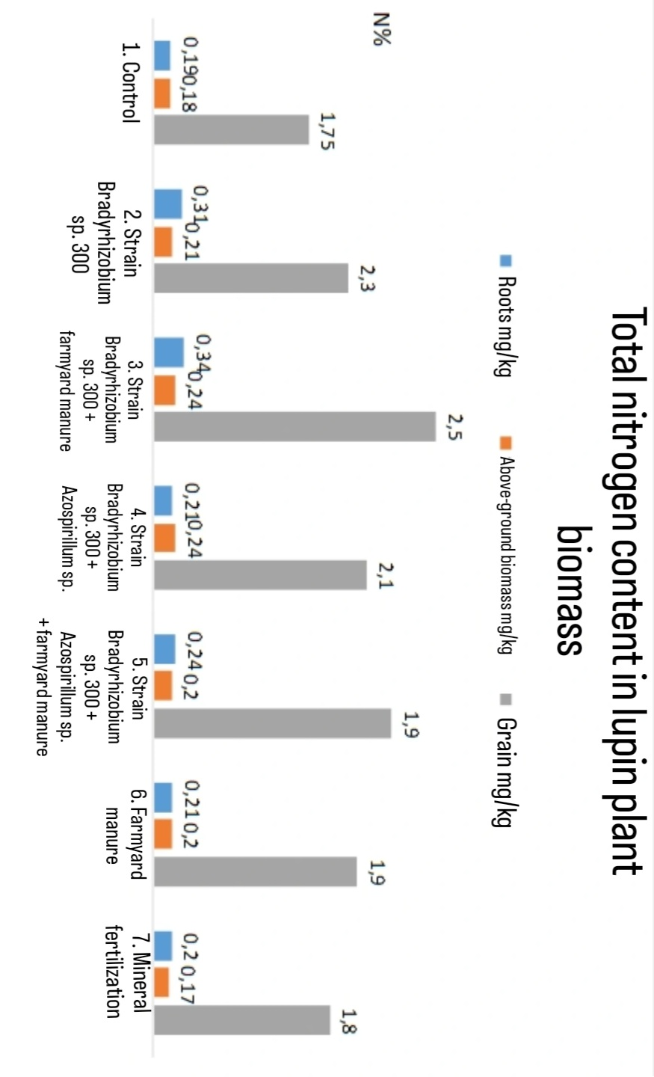
Figure 3. Total nitrogen content in the plant biomass of lupine.

4.3.4. Protein and Total Nitrogen Content in Lupine Grain
Data regarding the effect of the applied treatments show a significant increase in crude protein content in the grain, which was statistically significant across all variants relative to the control. The highest values were recorded in the variant inoculated with Bradyrhizobium sp. strain 300 + farmyard manure (129%). The smallest increase in grain crude protein content was observed in the mineral fertilization variant. The synergistic action of inoculation and farmyard manure application favors nitrogen accumulation, thereby enhancing crude protein synthesis in the grain.
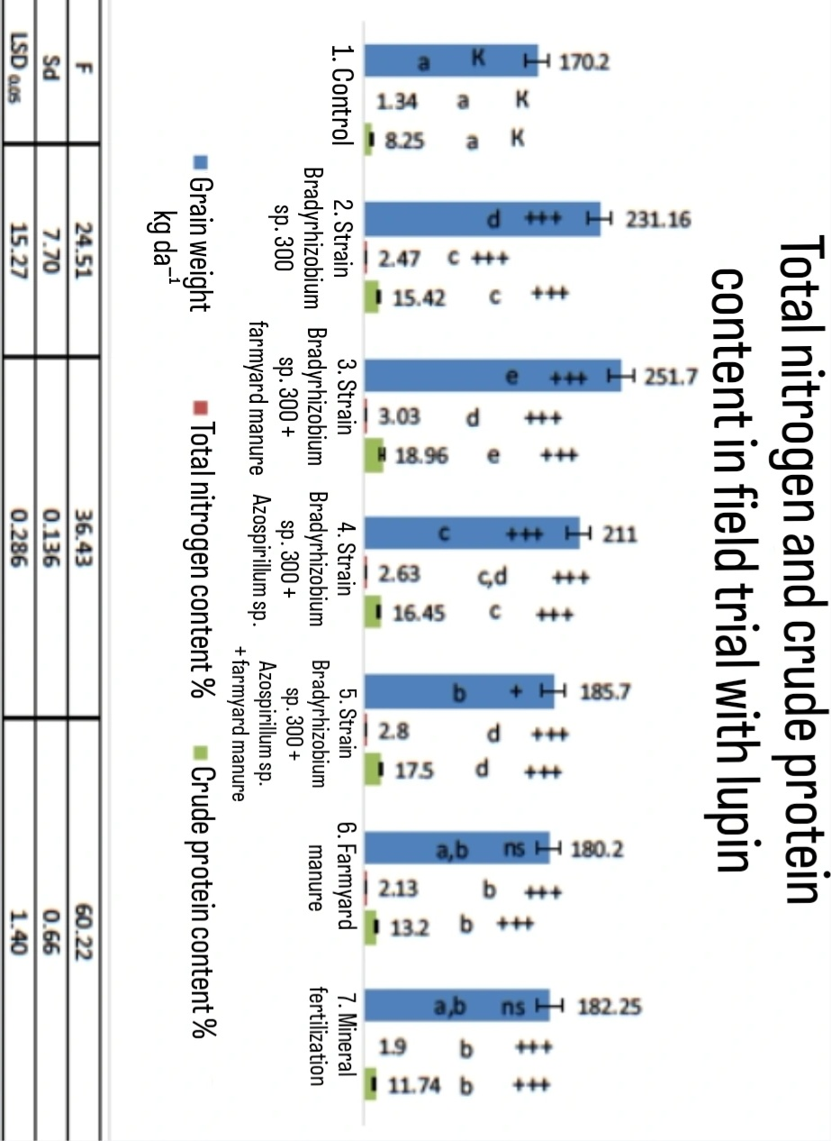
- + P < 0.05 – claim supported with 95% confidence
- ++ P < 0.01 – claim correct in 99% of cases
- +++ P < 0.001 – claim correct in 99.99% of cases
- ns – non-significant difference (statistically unproven difference)
Figure 4. Crude protein and total nitrogen content in the field experiment with lupine.

4.3.5. Effect of Inoculations with Nitrogen-Fixing Bacteria, Farmyard Manure, and Mineral Fertilizer on Plant Parameters and Yield of Lupine
The effect of the applied treatments across the two-year field experiments was significant, clearly demonstrating that lupine yield is affected to varying degrees across different plant morphological parameters (height, weight, etc.) (Figs. 14 and 15). The symbiosis between nitrogen-fixing bacteria of the genus Bradyrhizobium and white lupine produces maximum seed yield as well as seed protein yield. Mineral fertilization with nitrogen fertilizers does not significantly increase seed yield, protein content, or protein yield in inoculated plants (Ayisi et al., 1992).
Following the applied treatments, lupine stem height increased relative to the control in both years, with the response being most pronounced in the variant inoculated with Bradyrhizobium sp. strain 300 + farmyard manure. Regarding stem weight, the greatest increases were likewise observed in the variant inoculated with the same strain, showing a 27% increase in the first year and 60% in the second year (8).
With respect to root length, the applied treatments had a positive effect on root elongation. In the first year, the variant inoculated with Bradyrhizobium sp. strain 300 + farmyard manure exhibited an elongation of 92.3% relative to the control, and 86.9% in the second year (8). Root weight was also most significantly influenced by inoculation with Bradyrhizobium sp. strain 300 + farmyard manure in both years: by 36% in 2014 and by 82.2% in 2015 (Fig. 14 and 15).
Treatment effects were also observed in pod number and pod weight, with the greatest differences in values again established in the variant inoculated with Bradyrhizobium sp. strain 300 + farmyard manure (Fig. 14 and 15). In certain variants, a decrease in values relative to the control was noted (8). Regarding lupine grain weight, an increase in values was observed across all applied treatments; in the first year, the greatest differences relative to the control occurred in the variant inoculated with Bradyrhizobium sp. strain 300 + farmyard manure (49%), whereas in the second year the highest increase was recorded under dual inoculation with Bradyrhizobium sp. strain 300 + Azospirillum sp. 107 (Fig. 14 and 15).
Conclusion:
The applied treatments exerted a positive effect on plant parameters and yield across all variants, but the strongest influence was established under dual inoculation with Bradyrhizobium sp. strain 300 + Azospirillum sp. 107, which yielded the largest differences compared to the control. The smallest increases, or in some cases reductions in values relative to the control, were observed in variants receiving mineral fertilizer application (8).
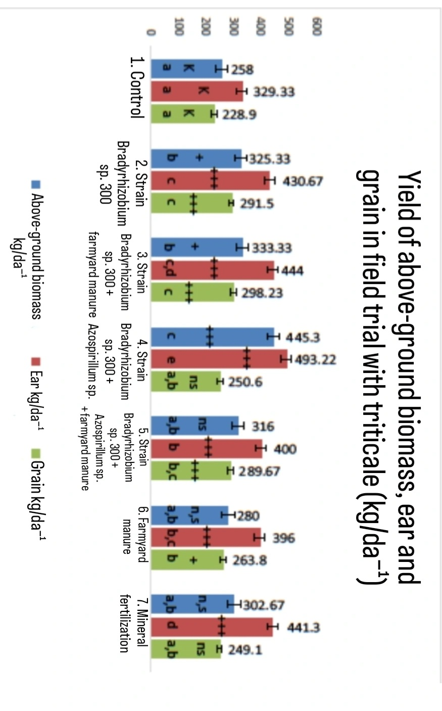
- + P < 0.5 – claim supported with 95% confidence
- ++ P < 0.01 – claim correct in 99% of cases
- +++ P < 0.001 – claim correct in 99.99% of cases
- ns – non-significant difference (statistically unproven difference)
Figure 5. Lupine yield in the second year of the field experiments.

4.4. Aboveground Biomass Yield of Triticale in a Field Experiment
Results obtained from the field experiment with triticale on Alluvial-meadow soil demonstrated that treatments applied during lupine cultivation exerted a positive residual effect on triticale yield (Fig. 19). Similar findings regarding increased triticale yields were reported by Carton et al. (2020).
The strongest statistically significant effect (P < 0.001) on the increase in aboveground biomass weight of triticale was observed in the variant inoculated with Bradyrhizobium sp. strain 300 + Azospirillum sp. 107 (76.70%), followed by the variant inoculated with Bradyrhizobium sp. strain 300 + farmyard manure at P < 0.5 (Fig. 19).
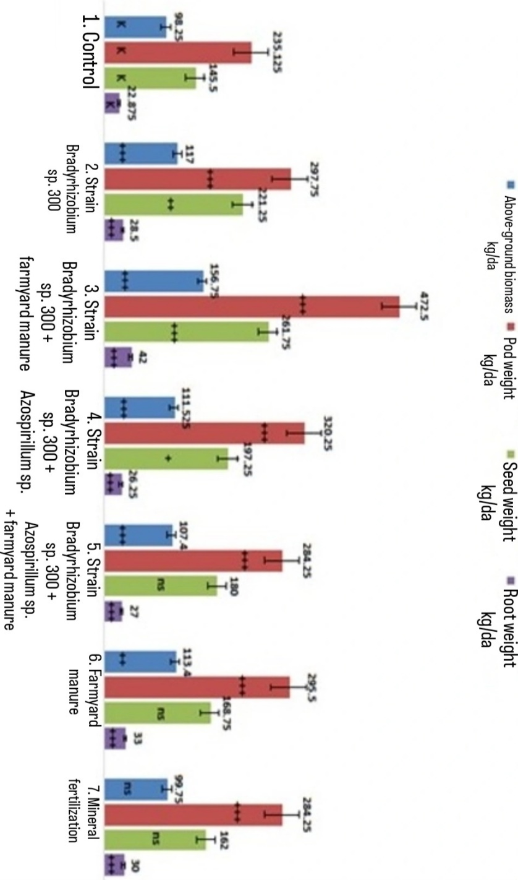
Figure 6. Aboveground biomass, spike, and grain yield in a field experiment with triticale (kg/da).

5. Conclusions
- Inoculation of sweet white lupine (cv. Lucky) positively influenced the development and abundance of the investigated physiological and taxonomic groups of microorganisms in the rhizosphere soil of the tested crop. The positive effect was most pronounced in the variants with single inoculation with Bradyrhizobium sp. strain 300 combined with farmyard manure application and dual inoculation with Bradyrhizobium sp. strain 300 + Azospirillum sp. 107.
- In the rhizosphere soil of lupine, microbial biomass, as well as the abundance of actinomycetes, diazotrophs, and oligonitrophils, can be considered sensitive indicators when assessing the impact of crop inoculation with nitrogen-fixing microorganisms.
- The amount of microbial biomass carbon in the rhizosphere soil during the pot experiment with lupine was positively affected by inoculation with Bradyrhizobium sp. strain 300 combined with farmyard manure application, as well as dual inoculation with the same strain and Azospirillum sp. 107.
- Total biological activity in the same experiment was stimulated to the highest degree by single inoculation with Bradyrhizobium sp. strain 300, followed by the combination of the same strain + farmyard manure, and dual inoculation with Bradyrhizobium sp. strain 300 + Azospirillum sp. 107.
- Statistically significant increases in fresh aboveground biomass weight of lupine were recorded following inoculation with Bradyrhizobium sp. strain 300, the same strain + farmyard manure, and dual inoculation with Bradyrhizobium sp. strain 300 + Azospirillum sp. 107. Root weight increased as a result of dual inoculation with Bradyrhizobium sp. strain 300 and Azospirillum sp. 107.
- The highest percentage increase in grain dry weight due to inoculation was recorded in the variant with single inoculation with Bradyrhizobium sp. strain 300 (122.2%), followed by dual inoculation with the same strain + Azospirillum sp. 107 (107.7%). Inoculation of lupine with Bradyrhizobium sp. strain 300 can be considered the most efficient inoculant selection for lupine, as evidenced by the highest grain yield, nodule count, and biological nitrogen fixation.
- Statistically significant increases in the percentage content of macronutrients (N, P, and K) in the grain during the pot experiment with lupine were established following single inoculation with Bradyrhizobium sp. strain 300, the same strain + farmyard manure application, and dual inoculation with Bradyrhizobium sp. strain 300 + Azospirillum sp. 107. Statistically proven increases in micronutrient content (Zn, Mn, Fe, Cu, Mg, and Ca) in lupine grain were also recorded under pot experiment conditions.
- As a result of single and joint inoculations with Bradyrhizobium sp. strain 300, Azospirillum brasilense sp. 107, and farmyard manure during sweet white lupine cultivation in the pot experiment, a significant increase in the content of macro- and micronutrients (N, P, K, Ca, Fe, Mn, Cu, and Zn) in the roots and aboveground biomass was demonstrated.
- Investigating the effect of inoculation with Bradyrhizobium sp. strain 300 and Azospirillum sp. 107 during lupine cultivation on Alluvial-meadow soil with and without organic fertilizer application on rhizosphere microflora under field conditions revealed a proven increase in soil nitrogen-transforming bacteria, as well as in groups decomposing complex organic compounds (such as actinomycetes and cellulose-decomposing microorganisms).
- Inoculation of sweet white lupine with Bradyrhizobium sp. strain 300 combined with farmyard manure application under field conditions proved to be the most effective treatment combination for achieving high biomass yield in the evaluated crop.
- Statistically significant increases in the content of investigated macro- and micronutrients in the grain, aboveground biomass, and roots of lupine were established, primarily driven by the combined application of Bradyrhizobium sp. strain 300 + farmyard manure, dual inoculation + farmyard manure, and single farmyard manure application.
- Inoculation of lupine with Bradyrhizobium sp. strain 300 combined with farmyard manure application significantly influenced the development and abundance of the evaluated physiological and taxonomic groups in the rhizosphere soil of the subsequent cereal crop—triticale. The positive residual effect was most pronounced in the variants inoculated with Bradyrhizobium sp. strain 300 + farmyard manure, Bradyrhizobium sp. strain 300 alone, and dual inoculation with Bradyrhizobium sp. strain 300 + Azospirillum sp. 107.
- The residual effect of combined application of Bradyrhizobium sp. strain 300 + farmyard manure and dual inoculation with Bradyrhizobium sp. strain 300 + Azospirillum sp. 107 during lupine cultivation resulted in statistically proven increases in grain weight, stem weight, and root weight in triticale. High statistical significance was also demonstrated for increases in stem height, as well as spike length and weight.
- Statistically significant increases in the content of investigated macro- and micronutrients in the grain, aboveground biomass, and roots of triticale were established as a consequence of treatments applied during the cultivation of the preceding crop—sweet white lupine (cv. Lucky).
- Optimal treatment combinations applied during lupine cultivation—inoculation with Bradyrhizobium sp. strain 300 + farmyard manure, single inoculation with Bradyrhizobium sp. strain 300, and dual inoculation with Bradyrhizobium sp. strain 300 + Azospirillum sp. 107—were identified as beneficial for enhancing the yield and quality of the subsequent cereal crop.

6. Contributions
- A comparative study of 7 Bradyrhizobium sp. (Lupinus) strains (Nos. 295, 296, 297, 298, 299, 300, and 301) from the collection of the "Soil Microbiology" Laboratory at the Department of "Physics, Erosion, and Soil Biota" (ISSAP "N. Poushkarov") was carried out for the first time under the soil-climatic conditions of Alluvial-meadow soil (Fluvisol, FAO).
- An effective combination involving Bradyrhizobium sp. strain 300 inoculation and farmyard manure application was selected for practical implementation, resulting in a substantial yield increase (up to 80%) in lupine under field conditions.
- The possibilities for dual inoculation combining symbiotic nitrogen-fixing bacteria (Bradyrhizobium) and associative nitrogen-fixing bacteria (Azospirillum) in lupine were investigated for the first time in Bulgaria.
- New insights were gained regarding the effects of nitrogen-fixing bacteria on nodulation, macro- and micronutrient accumulation, and biometric parameters in the understudied crop sweet white lupine (Lupinus albus saccharatus L.).
- A positive residual effect of inoculations with soil microorganisms of the genera Bradyrhizobium and Azospirillum on lupine was demonstrated regarding yield and biomass in subsequent cereal crops (triticale).

7. LIST OF PUBLICATIONS RELATED TO THE DISSERTATION
- Petrova, V., Dimitrova, A. (2016). Response of Lupinus albus to Inoculation with Nitrogen-fixing Bacteria and Manure Amendment on Alluvial–meadow Soil. Balkan Ecology, 19(2), 159–163.
- Petrova, V., Dimitrova, A. (2016). Influence of Bradyrhizobium sp. (Lupinus) Inoculations on Biological Activity and Soil Rhizosphere Microflora of Lupine. Balkan Ecology, 19(3), 239–244.
- Petrova, V. (2018). Influence of Inoculation with Nitrogen-fixing Bacteria and Manure on Yield of Lupin. Balkan Ecology, 21(4), 388–392.

