
AGRICULTURAL ACADEMY

INSTITUTE OF SOIL SCIENCE, AGROTECHNOLOGIES AND PLANT PROTECTION "NIKOLA POUSHKAROV"

Dimitar Ivanov Velchev

POSSIBILITIES FOR APPLYING BIOLOGICAL MEANS FOR MONITORING AND CONTROL OF INSECT PESTS ON MAIZE

ABSTRACT

of a dissertation for the acquisition of the educational and scientific degree "Doctor" (PhD)
Scientific Specialty: Plant Protection (Entomology)
Professional Field: 6.2 Plant Protection

Scientific Advisors: Prof. Olya Evtimova Karadjova, PhD
Assoc. Prof. Teodora Borislavova Toshova, PhD

Reviewers: academic degree, academic rank, First Name, Middle Name, Last Name
academic degree, academic rank, First Name, Middle Name, Last Name

Sofia, 2026

The dissertation consists of 148 pages and includes 10 tables and 64 figures. A total of 274 literary sources were used, including 30 in Cyrillic and 244 in Latin script. The numbering of the tables and figures in this abstract does not correspond to the numbering in the dissertation.
The defense of the dissertation thesis will take place on ............... at ....... h ........................................................................ at an open session of the Scientific Jury, Order No. RD ................. 2026 of the President of the Agricultural Academy.

Scientific Jury:
Internal Members:
- Assoc. Prof. Zhenya Ivanova Ilieva, PhD (Nikola Pushkarov Institute of Soil Science, Agrotechnologies and Plant Protection, Agricultural Academy, Sofia)
- Assoc. Prof. Vasilina Dimcheva Maneva, PhD (Institute of Agriculture, Karnobat, Agricultural Academy)
External Members:
- Cor. Mem. Prof. Georgi Tsvetkov Georgiev, DSc (Forest Research Institute, BAS, Sofia)
- Assoc. Prof. Katya Georgieva Trencheva, PhD (University of Forestry, Sofia)
- Assoc. Prof. Dima Mateeva Markova, PhD (Agricultural University, Plovdiv)

Alternate Members:
- Assoc. Prof. Mariya Ivanova Stoyanova, PhD (Nikola Pushkarov Institute of Soil Science, Agrotechnologies and Plant Protection, AA, Sofia) – internal member
- Assoc. Prof. Albena Georgieva Gyonova, PhD (Sofia University "St. Kliment Ohridski", Faculty of Biology, Sofia) – external member

List of Abbreviations and Symbols

BFSA – Bulgarian Food Safety Agency
CIs – Confidence Intervals
EIL – Economic Injury Level
EO – Essential oil or essential oils (depending on the context)
IPM – Integrated Pest Management
MRI – Maize Research Institute
(±)-linalool – linalool
nonanal – 9Al
(E)-2-hexen-1-ol – E2-6OH
(Z)-3-hexen-1-ol – Z3-6OH
(Z)-3-hexenyl butyrate – Z3-6Bu
LC₅₀ – concentration required to cause 50% mortality in the test individuals
LC₉₀ – concentration required to cause 90% mortality in the test individuals
LT₅₀ – median lethal time
PE – polyethylene, polyethylene (adj.)
SE – standard error

INTRODUCTION

The history of modern maize, Zea mays Linnaeus, 1753 (Poaceae), dates back approximately 7,000–10,000 years and traces its origin to teosinte (Euchlaena mexicana sensu lato), a wild grass native to present-day Mexico (Goodman and Galinat, 1988). Maize is one of the world's most important agricultural crops, with extensive applications in food production, animal feed, and various industrial sectors (Shiferaw et al., 2011; Ranum et al., 2014).
In Bulgaria, maize is the second most important field crop after wheat. According to the Annual Agricultural Reports of the Ministry of Agriculture and Food, approximately 500,000 hectares have been harvested with maize in recent years, representing between 9% and 13% of the country's total utilized agricultural area. Bulgaria has a long tradition of maize production, and numerous domestic hybrids have been developed at the Maize Research Institute (MRI) of the Agricultural Academy in Knezha, which is located in one of the most favourable agroecological regions for maize cultivation in the country.
The major insect pests of Z. mays in Bulgaria include the grey maize weevil Tanymecus dilaticollis Gyllenhal, 1834 (Coleoptera: Curculionidae), wireworms and false wireworms (Coleoptera: Elateridae and Tenebrionidae), the European corn borer Ostrinia nubilalis (Hübner, 1796), the cotton bollworm Helicoverpa armigera (Hübner, 1808) (Lepidoptera: Noctuidae), aphids (Hemiptera: Aphididae), predominantly Aphis fabae subsp. evonymi Fabricius, 1775, Rhopalosiphum maidis (Fitch, 1856), and Sipha maydis Passerini, 1860; the cereal leaf beetle Oulema melanopus (Linnaeus, 1758) (Coleoptera: Chrysomelidae), and the field cricket Melanogryllus desertus (Pallas, 1771) (Grylloidea) (Tomov and Yordanov, 1988; BFSA, 2017).
Since the late twentieth and early twenty-first centuries, several invasive insect species have also been recorded as maize pests. These include the western corn rootworm Diabrotica virgifera virgifera LeConte, 1858 (Coleoptera: Chrysomelidae), Reptalus panzeri (Löw, 1883), and the planthopper Hyalesthes obsoletus Signoret, 1865 (Auchenorrhyncha: Cixiidae), the latter two being vectors of stolbur phytoplasma (Ivanova, 2002a; Genov et al., 2014). The invasive brown marmorated stink bug, Halyomorpha halys (Stål, 1855) (Heteroptera: Pentatomidae), a highly polyphagous species that also attacks maize, was first reported in Bulgaria in 2016 (Simov, 2016). More recently, the fall armyworm, Spodoptera frugiperda (J. E. Smith, 1797) (Lepidoptera: Noctuidae), an economically important pest of numerous crops, including maize, has been detected in Bulgaria through independent monitoring studies using pheromone traps, food-baited traps, and light traps (Szanyi et al., 2025).
The present study focuses on three economically important coleopteran pests of maize in Bulgaria: Tanymecus dilaticollis, Diabrotica virgifera virgifera, and Oulema melanopus (Fig. 1).

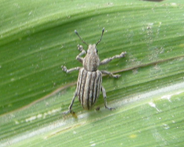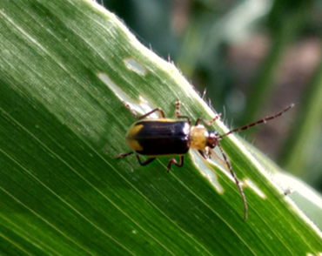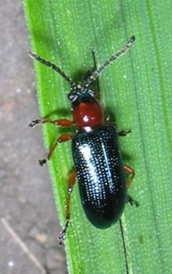
Fig. 1. Tanymecus dilaticollis (left), Diabrotica virgifera virgifera (centre), and Oulema melanopus (right).

1. LITERATURE REVIEW
The current policy of the European Union in the field of plant protection aims to reduce the risks associated with the use of plant protection products (PPPs) while promoting sustainable agricultural practices. The foundations of this policy are laid down in Regulation (EC) No. 1107/2009, Directive 2009/128/EC, and subsequent European legislation establishing a harmonised regulatory framework for the safe and sustainable use of PPPs. In line with the objectives of the European Green Deal and the Farm to Fork Strategy, the European Commission has set a target of reducing both the use of and the risks associated with chemical pesticides by 50% by 2030, while encouraging the implementation of environmentally sustainable plant protection methods.
The literature review presents the contemporary concept of Integrated Pest Management (IPM), which is based on systematic pest monitoring and decision-making according to established Economic Injury Levels (EILs). Particular attention is paid to the role of semiochemicals, bioinsecticides, and plant-derived products, particularly essential oils.
For each of the target insect species, the available information on geographical distribution, biology, Economic Injury Levels (EILs), control measures, chemical communication, and natural enemies is reviewed.

2. AIM AND OBJECTIVES
The aim of the present study was to identify attractants for the grey maize weevil (Tanymecus dilaticollis) and to obtain evidence of pheromone communication in this species; to investigate the potential practical application of attractive organic compounds for Tanymecus dilaticollis and Diabrotica virgifera virgifera; and to evaluate the efficacy of biological control products against T. dilaticollis, D. v. virgifera, and Oulema melanopus.
To achieve this aim, the following objectives were established:
- to evaluate the biological activity of candidate attractant compounds identified by collaborators through electrophysiological studies or chemical analyses of volatile organic compound blends against adults of T. dilaticollis;
- to optimise the lure composition, dispenser type, and trap design for monitoring T. dilaticollis;
- to monitor the seasonal activity of adult grey maize weevils and western corn rootworms using traps based on chemical or visual stimuli;
- to evaluate biological plant protection products (entomopathogenic fungi, entomopathogenic nematodes, and essential oil) against T. dilaticollis, D. v. virgifera, and O. melanopus.
Based on the aim and objectives of the study, the following research hypotheses were formulated:
Hypothesis 1. Some volatile organic compounds identified through electrophysiological studies exhibit attractive activity towards adult Tanymecus dilaticollis of both sexes.
Hypothesis 2. The efficiency of monitoring overwintered adults of the grey maize weevil can be improved by optimising lure composition, dispenser type, and trap design.
Hypothesis 3. Traps employing chemical or visual stimuli provide reliable information on the seasonal activity and relative abundance of Tanymecus dilaticollis and Diabrotica virgifera virgifera.
Hypothesis 4. Intraspecific chemical communication occurs among adult Tanymecus dilaticollis.
Hypothesis 5. Entomopathogenic fungi, entomopathogenic nematodes, and natural essential oils have the potential to reduce populations of Tanymecus dilaticollis, Diabrotica virgifera virgifera, and Oulema melanopus.

3. MATERIALS AND METHODS

3.1. Tanymecus dilaticollis

3.1.1. Compounds used in trapping experiments
Synthetic compounds purchased from Sigma–Aldrich® or supplied by scientists from Rothamsted Research (United Kingdom) were used in the field experiments. The purity of all compounds exceeded 95%. The tested compounds included the aliphatic compounds (E)-2-hexen-1-ol (E2-6OH), (Z)-3-hexen-1-ol (Z3-6OH), (Z)-3-hexenyl butyrate (Z3-6Bu), nonanal (9Al), the aromatic compound (±)-linalool (linalool), and the terpene caryophyllene.

3.1.2. Lures
The following dispensers were used:
- Dental cotton rolls (Celluron®, Paul Hartmann AG, Heidenheim, Germany) enclosed in polyethylene bags made of 0.02-mm linear polyethylene film and pre-mounted on plastic holders (8 × 1 cm) (PE cotton dispensers);
- Polyethylene containers with lids, 2.5 ml (Just Plastics Ltd, United Kingdom) (Just Plastics PE containers, 2.5 ml);
- Polyethylene vials with lids, 1 ml (Kartell®, Italy) (Kartell PE vials, 1 ml).
The compounds were applied individually or as mixtures to the dispensers in 100 μl aliquots using an automatic micropipette fitted with disposable tips. The only exception was the experiment evaluating different ratios of two compounds.

3.1.3. Traps
TAL traps (CSALOMON®, Hungary) were used in most experiments. The lure dispensers were attached beneath the transparent roof of the trap. The collecting container was buried in the soil to a depth corresponding to its height. A rectangular sheet (16 × 10 cm) of transparent PVC film coated with a water-insoluble insect adhesive (Tanglefoot®, USA) was placed at the bottom of the trap as the killing agent.

3.1.4. Trapping experiments
The field experiments were conducted with three or four replicates arranged in blocks, each containing all lure and/or trap treatments. Unbaited traps served as controls in all experiments. The distance between traps within each block exceeded 7 m, while the distance between blocks ranged from 30 to 40 m. Trap catches were recorded at intervals of 1–3 days. Data obtained from regular inspections of TAL sticky traps baited with synthetic plant-derived compounds during the 2009, 2011, and 2013 field experiments were used to monitor the seasonal activity of overwintered adults of the grey maize weevil. Detailed descriptions of the experiments are presented in Section 4, “Results and Discussion”.
Species identification was performed using the taxonomic keys of Angelov (1978, 1980).

3.1.5. Evaluation of the efficacy of the bioinsecticide Naturalis against Tanymecus dilaticollis under field conditions
The efficacy of the bioinsecticide Naturalis (CBC (Europe) S.r.l., Italy) against adult grey maize weevils was evaluated under field conditions between 3 May and 4 June 2021. Three treatments, each with three replicates, were tested in maize plots:
- Naturalis at 200 ml/da;
- Naturalis at 100 ml/da;
- Control (tap water).
The experiment was arranged according to a Latin square design. Individual experimental plots measured 42 m², with 3-m buffer zones between blocks. The total experimental area was 630 m². The maize hybrid Kn-442 was used throughout the experiment.

3.1.6. Effect of white oregano essential oil on adult Tanymecus dilaticollis under laboratory conditions
Two parallel laboratory experiments were conducted between 25 April and 4 May 2022 to evaluate the effect of white oregano, Origanum vulgare ssp. hirtum (Link) Ietswaart (or Greek oregano), essential oil (EO) on adult grey maize weevils. In the first experiment, 1 ml of each test solution was applied to filter paper discs placed on the bottom of sterile Petri dishes, after which 20 adult insects were introduced into each dish. In the second experiment, 2 μl of each EO concentration was applied directly to each of 20 adult insects, which were subsequently transferred to sterile plastic containers for mortality observations. Each insect was treated individually with a single concentration by applying the solution between the pronotum and the abdomen using an automatic micropipette fitted with disposable tips. Both experiments consisted of three replicates. The numbers of live and dead insects were recorded every 24 h.

3.1.7. Effect of white oregano essential oil on maize under laboratory conditions
The following concentrations of aqueous white oregano EO solutions containing 0.01% Tween emulsifier were evaluated: 0.1 μl/ml, 1 μl/ml, 10 μl/ml, and 100 μl/ml. Distilled water and distilled water containing 0.01% Tween 80 served as controls. For comparison, the systemic insecticide Mospilan 20 SP (Nippon Soda Co., Ltd., Tokyo, Japan), containing the active ingredient acetamiprid, was included at the recommended field rate of 10 g/da for the control of the grey maize weevil. Each treatment was tested in three replicates. Maize plants at the two- to three-leaf stage (BBCH 12–13) were sprayed with 4 ml of the corresponding working solution using 12-ml plastic spray bottles (Shopiens). Plant condition was assessed daily for ten consecutive days.
Phytotoxicity in young maize plants was evaluated according to the scale (Machado et al., 2024), as follows:
- 0 – no injury;
- 1 – slight symptoms;
- 2 – moderate symptoms;
- 3 – severe symptoms;
- 4 – very severe symptoms.

3.1.8. Effect of white oregano essential oil on maize under field conditions
Maize plants were treated with white oregano essential oil (EO) at concentrations of 0.1 μl/ml, 1 μl/ml, 10 μl/ml, and 100 μl/ml, as well as with Mospilan 20 SP at the recommended rate of 10 g/da. Distilled water and distilled water containing 0.01% Tween emulsifier served as the control treatments. The field experiment was established as a randomized complete block design with three replicates. Plant observations were carried out daily for 10 consecutive days. Fresh plant biomass (stems and leaves) was measured two weeks after the completion of the observation period.

3.1.9. Effect of entomopathogenic nematode products under field conditions
The following commercial products were evaluated:
- Nemastar® (powder formulation containing 5 million Steinernema carpocapsae);
- Nematop® Käfer-Stopp Trap (a wooden trap with grooves on the upper surface filled with a gel containing 2.5 million S. carpocapsae infective juveniles).
The powdered formulation Nemastar® was evaluated under field conditions in maize fields established with two different seed treatment practices: chemical seed treatment (Gaucho® 600 FS) and biological seed treatment (Naturalis combined with microbial fertilizers). Field experiments (open maize plots of 25 m²) and semi-field experiments (wooden cages covered with insect-proof mesh; 0.5 m³; four maize plants per cage) were conducted under both seed treatment regimes. Two Nemastar® treatments, each with two replicates, and one untreated control receiving tap water only were included. The distance between plots within a block was 15–20 m, while cages were spaced 10–15 m apart. During the first Nemastar® application (28 April 2022), no additional weevils were released into the open plots, whereas 15 adult weevils were introduced into each cage. During the second application (19 May 2022), 70 weevils were released into each open plot and 30 adults into each cage. Prior to the second treatment, 20 L of water was applied to each open plot and 1.5 L to each cage in order to increase soil moisture and facilitate the movement of the entomopathogenic nematodes through the soil. Two Nematop® Käfer-Stopp traps were placed on the soil surface in the field with biologically treated seeds, whereas one trap was installed in the field established with Gaucho® 600 FS-treated seeds on 28 April 2022. Following installation, the traps were irrigated daily for three consecutive days to maintain adequate moisture for nematode activity. Dead insects collected from all experiments were stored under refrigeration for 1–5 days prior to dissection. Temporary microscope slides were prepared and examined under light microscopes to determine the presence of entomopathogenic nematodes.

3.2. Diabrotica virgifera virgifera

3.2.1. Monitoring the seasonal activity of adult Diabrotica virgifera virgifera using unbaited coloured sticky traps
Between 5 June and 23 September 2014, sticky PVC traps (10 × 16 cm; CSALOMON®, Hungary) of the following colours were evaluated in six replicates: white, blue, red, orange, yellow, and fluorescent yellow. Transparent (colourless) traps were used as controls. Trap catches were recorded once or twice weekly, after which the used sticky traps were collected and replaced with new ones.

3.2.2. Monitoring the seasonal activity of adult Diabrotica virgifera virgifera using KLP+ traps baited with pheromone and floral lures
Field studies were conducted during 2015 (17 June–30 September) and 2016 (12 July–28 September) using KLP+ traps equipped with two semiochemical lures (a pheromone lure and a floral lure) manufactured by CSALOMON®. Each trap contained a Vaportape® insecticide strip (Hercon Environmental Inc., Emigsville, PA, USA) serving as the killing agent for captured beetles. Baited traps were deployed in four replicates, while unbaited control traps were placed within the second and fourth replicate blocks. Lures were replaced with fresh ones at four-week intervals.

3.2.3. Effect of yellow colour hue of the trap in combination with pheromone and plant lures
During 2017 (21 July–2 October; lure replacement on 18 August) and 2018 (15 July–30 September; lure replacement on 15 August), the attractiveness of standard yellow and fluorescent yellow KLP+ dry insecticide traps was compared. Both trap types were baited with a pheromone lure and a floral lure supplied by CSALOMON®. Each treatment was evaluated in two replicates during both study periods.

3.2.4. Monitoring the seasonal activity of adult Diabrotica virgifera virgifera in maize fields established with different seed treatment (biological and chemical)
Between 29 June and 12 September 2022, the seasonal activity of adult western corn rootworms was monitored using KLP traps baited with both pheromone and floral lures in maize fields established with different seed treatment regimes: biological seed treatment (two replicates) and chemical seed treatment (one replicate).

3.2.5. Experimental insects for laboratory studies
The adult individuals of the western corn rootworm were collected using pheromone and floral lures supplied by CSALOMON® in order to capture both male and female beetles. Collections were carried out between 09:00 and 12:00 h, corresponding to the period of highest flight activity of adults towards both lure types.

3.2.6. Effect of white oregano essential oil on adult Diabrotica virgifera virgifera under laboratory conditions
Randomly selected adult D. v. virgifera of unknown sex and age, collected from a maize field in early August 2021, were used in the bioassays. Two laboratory experiments were conducted to evaluate the biological activity of white oregano essential oil (EO) against adults of the western corn rootworms. In a preliminary experiment, three volumes of undiluted white oregano EO (3 μl, 5 μl, and 10 μl) were tested to assess its biological activity. Each volume was applied separately to the filter paper lining the bottom of a Petri dish using an automatic micropipette. In the subsequent experiment, the activity of white oregano EO was evaluated in distilled water containing 0.01% (v/v) Tween 80®. The tested concentrations were 0.01 μl/ml, 0.1 μl/ml, 1 μl/ml, and 10 μl/ml. One millilitre of each solution was applied separately to the filter paper covering the bottom of a sterile Petri dish (85 mm diameter × 17 mm height). In the control treatment, the filter paper was treated with 1 ml of distilled water containing 0.01% (v/v) Tween 80®. The experiments were performed in 3 replicates, with the number of experimental insects in a Petri dish being 24 (SE: ± 3) in the first experiment and 28 (SE: ± 1) in the second.

3.2.7. Evaluation of the lethal effect of a Metarhizium pemphigi strain on adult Diabrotica virgifera virgifera under laboratory conditions
The Metarhizium pemphigi (Driver и R.J. Milner) Kepler, S.A. Rehner и Humber strain AMEP28 used in this study was isolated from an unidentified ground beetle (Coleoptera: Carabidae) and was kindly provided by Dr. Marek Barta (Institute of Forest Ecology, Nitra, Slovakia) for collaborative research. The following conidial suspensions were evaluated: 2 × 10³, 2 × 10⁴, 2 × 10⁵, 2 × 10⁶, and 2 × 10⁷ conidia/ml. The insecticidal activity of the entomopathogenic fungus was assessed using the filter paper bioassay method. One millilitre of each conidial suspension was applied to a filter paper disc placed at the bottom of a sterile Petri dish. Randomly selected adult D. virgifera virgifera of unknown sex and age were used in the experiment. A total of 413 adult individuals were used in this bioassay. The numbers of live and dead insects were recorded daily for 10 days following treatment. Dead insects were transferred to new Petri dishes (55 mm diameter) lined with moist filter paper and incubated at 24 ± 1 °C to confirm fungal outgrowth (mycosis).

3.3. Oulema melanopus

3.3.1. Experimental insects for laboratory studies
Adults and larvae of Oulema melanopus were collected by hand from an oat field at the MRI, Knezha. Adult beetles were collected in June 2019, whereas larvae were collected in June 2021. Species identification was performed using the identification key of Gruev and Tomov (1986). The larvae were approximately 6 mm in length. The head capsule width of randomly selected larvae corresponded to the third and fourth larval instars according to Hoxie and Wellso (1974).

3.3.2. Evaluation of the efficacy of the bioinsecticide Naturalis against adult Oulema melanopus under laboratory conditions
The following conidial suspensions of Naturalis were evaluated in Petri dishes with three replicates per treatment: 2.3 × 10² – 2.3 × 10⁷ conidia/ml. One millilitre of each suspension was applied to the filter paper lining the bottom of a sterile plastic Petri dish (ISOLAB, 85 mm diameter) using an automatic micropipette fitted with disposable tips. In the control treatment, also performed in three replicates, 1 ml of distilled water was applied instead. Subsequently, 21 adult of the cereal leaf beetle were introduced into each Petri dish. Insect mortality was recorded at 24-h intervals for 10 days after treatment. Dead insects were transferred to new Petri dishes containing filter paper moistened with distilled water and incubated to allow fungal outgrowth (mycosis).

3.3.3. Evaluation of the efficacy of the bioinsecticide Naturalis against Oulema melanopus larvae under laboratory conditions
The same serial dilutions of Naturalis used in the adult bioassay were prepared in distilled water (2.3 × 10² – 2.3 × 10⁷ conidia/ml). One millilitre of each concentration, including the undiluted commercial formulation (2.3 × 10⁷ conidia/ml), was evenly distributed over the surface of the filter paper placed at the bottom of a sterile Petri dish (ISOLAB, 85 mm diameter). Distilled water (1 ml) was used in the control treatment. Each treatment was evaluated in three replicates, with 20 larvae placed in each Petri dish. Mortality assessments and post-mortem examination for fungal development were performed according to the methodology described in Section 3.3.2.

3.4. Data analysis
The data were analysed using either the non-parametric Kruskal–Wallis H test or analysis of variance (ANOVA), depending on the characteristics of the dataset. When significant differences among treatment means were detected, post hoc pairwise comparisons were performed using the Mann–Whitney U test following the Kruskal–Wallis test or Least Significant Difference (LSD) test following ANOVA. Probit analysis was used to estimate the median lethal concentration (LC₅₀), the concentration causing 90% mortality (LC₉₀), the median lethal time (LT₅₀), and their corresponding 95% confidence intervals (CIs). Statistical analyses were performed primarily using STATISTICA 7.0 (StatSoft, Inc., 2004) and Microsoft Excel. Differences were considered statistically significant at P ≤ 0.05.

3.5. Study area and meteorological data

The soils in the vicinity of the Maize Research Institute (MRI), Knezha, are classified as typical chernozem, while the climate is temperate continental. The meteorological data presented in this dissertation were provided by the Meteorological Station in Knezha.
4. RESULTS AND DISCUSSION

4.1. Tanymecus dilaticollis
4.1.1. Effect of lure composition
Experiment 1. In 2009, Tanymecus dilaticollis adults were captured in all trap treatments baited individually with (E)-2-hexen-1-ol (E2-6OH), (Z)-3-hexen-1-ol (Z3-6OH), or (±)-linalool, as well as in the unbaited control traps. Analysis of the results from the first field experiment showed that the mean catches in traps baited with each of the tested compounds were significantly higher than those recorded in the unbaited control traps (Fig. 2). The highest mean catches were obtained in traps baited with E2-6OH and Z3-6OH.

Fig. 2. Mean catches (± SE) of adult Tanymecus dilaticollis in TAL sticky traps, 21 May–10 June 2009, Knezha, Bulgaria, three replicates. Bars marked with the same letter are not significantly different (P ≤ 0.05, Kruskal–Wallis test followed by the Mann–Whitney U test).
Experiment 2. During the second field experiment conducted in 2009, adults of the target species were captured in all trap treatments regardless of whether the traps were baited or unbaited. The results demonstrated that adult grey maize weevils were most strongly attracted to lures baited individually with the two unsaturated alcohols, E2-6OH and Z3-6OH, or with their ternary blend containing (±)-linalool (E2-6OH : Z3-6OH : linalool = 1 : 1 : 1). Mean catches in traps baited with the remaining test compounds, namely (±)-linalool, caryophyllene, and nonanal (9Al), did not differ significantly from those recorded in the unbaited control traps (P > 0.05) (Fig. 3).

Fig. 3. Mean catches (± SE) of adult Tanymecus dilaticollis in TAL sticky traps between 11 and 29 June 2009 using PE cotton dispensers, Knezha, Bulgaria (three replicates).
Experiment 3. The results of the 2011 field experiment showed that the highest number of adult Tanymecus dilaticollis was captured in TAL sticky traps baited with the binary blend of (Z)-3-hexen-1-ol (Z3-6OH) and (E)-2-hexen-1-ol (E2-6OH) at a 1:1 ratio, followed by traps baited with Z3-6OH alone. However, the mean catches in these two treatments did not differ significantly (Fig. 4A). Traps baited with the binary lure captured more than three times as many adult weevils as the unbaited control traps.
In addition to the grey maize weevil, adults of the black beet weevil, Psallidium maxillosum Dejean, 1821, were also captured during this experiment. As observed for T. dilaticollis, the mean catches of P. maxillosum in traps baited with the Z3-6OH + E2-6OH (1:1) blend were significantly higher than those recorded in the unbaited control traps (Fig. 4B).
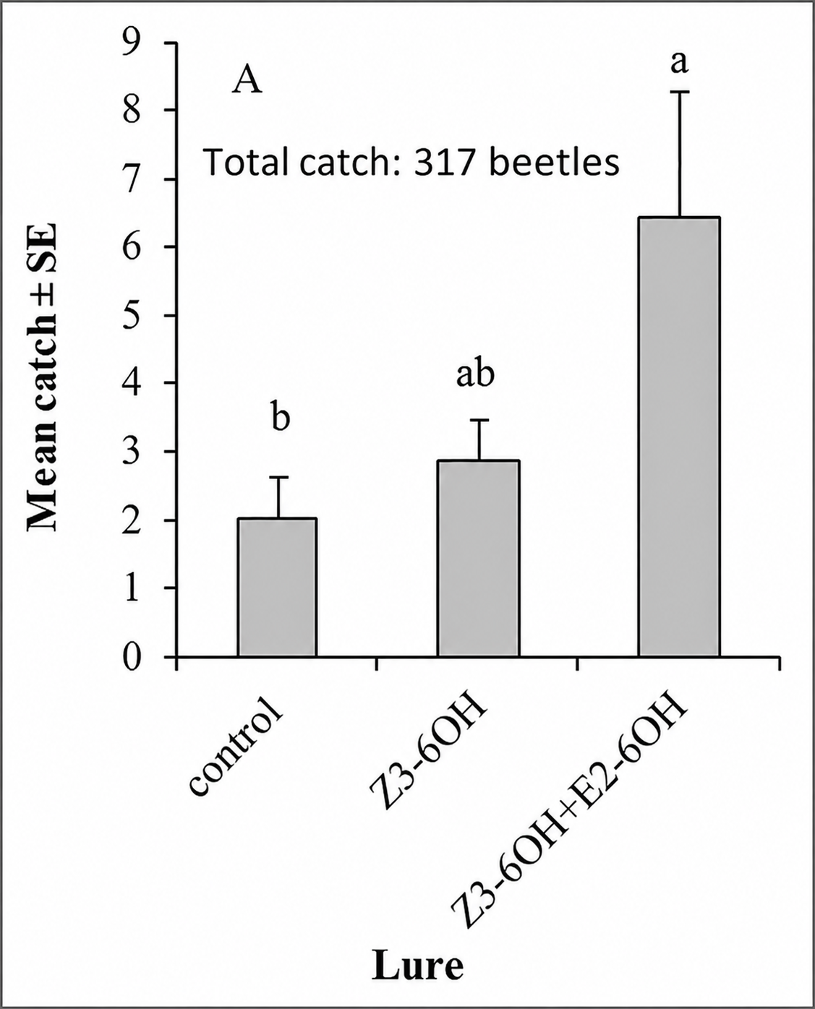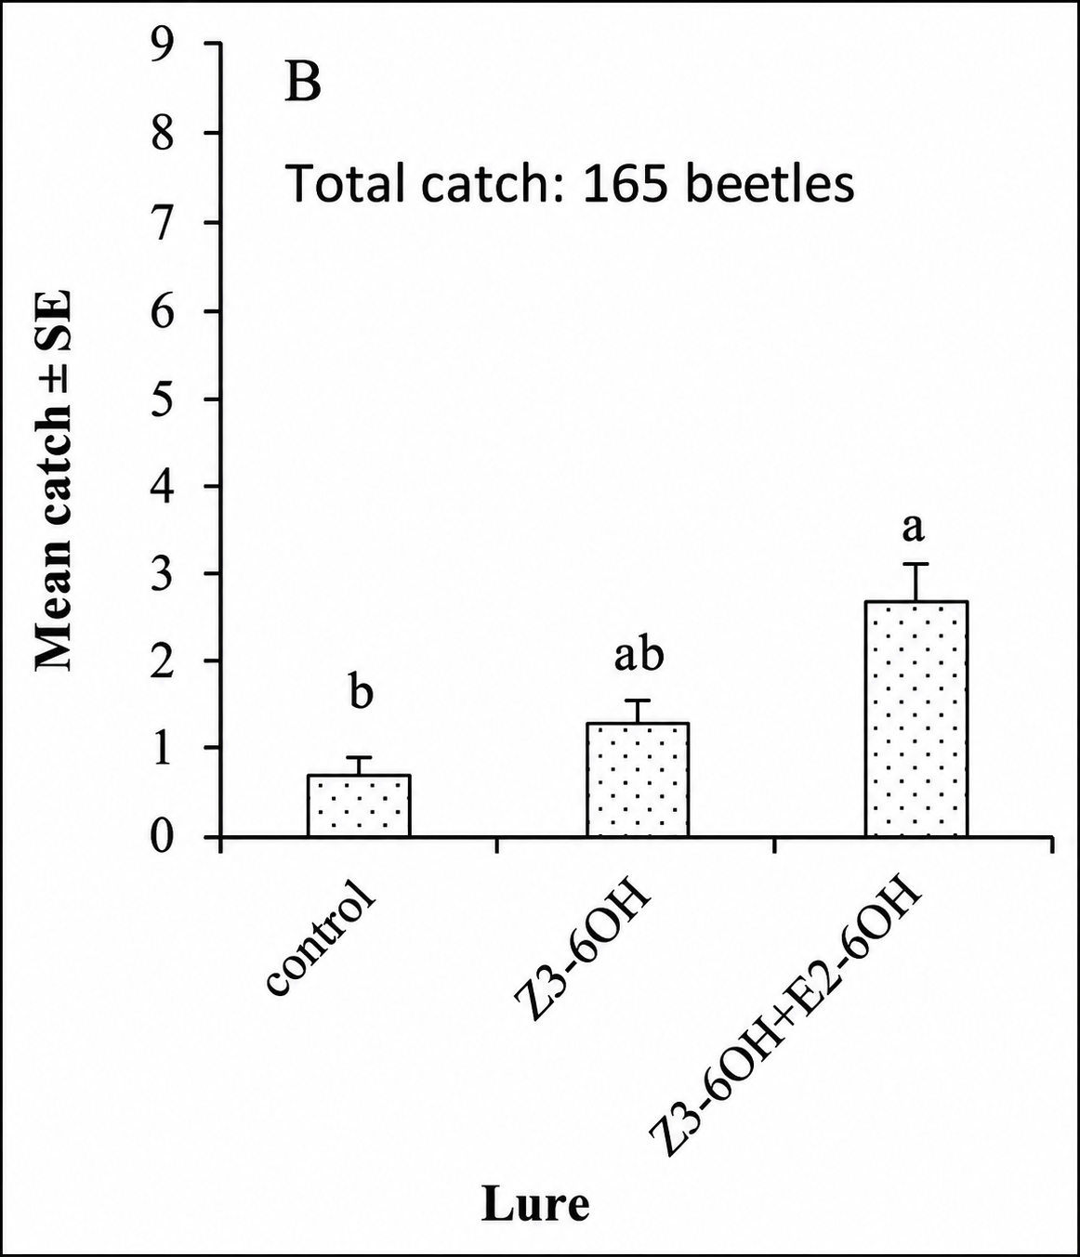
Fig. 4. Mean catches (± SE) of Tanymecus dilaticollis (A) and Psallidium maxillosum (B) in TAL sticky traps baited with different lures loaded into Just Plastics PE 2.5-ml containers and in unbaited control traps, Knezha, Bulgaria, 14 April–19 May 2011, four replicates. For statistical annotations, see Fig. 2.
Experiment 4. Comparison of catches of the grey maize weevil in traps baited with (Z)-3-hexenyl butyrate (Z3-6Bu) and in unbaited control traps showed that catches in the control traps were significantly higher than those in baited traps, indicating that the tested compound exerted a significant inhibitory (repellent) effect on Tanymecus dilaticollis (t-test).
Experiment 5. The attractiveness of lures containing different ratios of Z3-6OH and E2-6OH was evaluated: (1) 100:10, (2) 100:50, (3) 100:100, (4) 50:100, (5) 10:100, and (6) 200:200. The highest mean catches of T. dilaticollis were recorded in traps baited with the 1:1 blends (100:100 and 200:200). However, no statistically significant differences were detected among the catches obtained with the different blend ratios (Kruskal–Wallis χ² = 5.895, P = 0.435).
4.1.2. Effect of dispenser type on lure activity
Experiment 6. The results of this experiment, in which the same binary lure (Z3-6OH + E2-6OH, 1:1) was used with three different dispenser types, showed that the mean catches of adult T. dilaticollis were significantly higher in traps equipped with Just Plastics PE 2.5-ml containers than in traps using the other two dispenser types, namely PE cotton dispensers and Kartell 1-ml PE vials. No significant difference was found between the mean catches obtained with PE cotton dispensers and Kartell 1-ml PE dispensers.
4.1.3. Effect of trap design
Experiment 7. The effect of trap design on the catches of T. dilaticollis was evaluated using the same binary lure (Z3-6OH + E2-6OH) loaded into Just Plastics PE containers. The following trap types were compared: (1) TAL sticky traps (Csalomon®, Hungary), (2) YATLOR funnel traps (RO.SA. Micromecanica s.a.s., Italy), (3) Pherocon® Boll Weevil Traps (Trece Inc., USA; cone traps), and (4) round pitfall traps (14 cm diameter, 8 cm depth) fitted with a funnel and a 30 × 30 cm plastic rain cover. The experiment was conducted with four replicates.
The highest catches of the grey maize weevil were recorded in TAL sticky traps, with catches significantly exceeding those obtained with the other trap types. Mean catches in TAL sticky traps were approximately four times higher than those recorded in the remaining trap designs.
4.1.4. Monitoring the seasonal activity of adult Tanymecus dilaticollis using sticky traps
Although the experiment in 2009 did not cover the beginning and the end of the seasonal activity of T. dilaticollis in the Knezha region because trapping started relatively late, Fig. 5 shows that adults were captured at every sampling date between 21 May and 29 June 2009 in traps baited with single-compound lures (except during the last two sampling dates in June for traps baited with E2-6OH). No distinct peaks in trap catches were observed during this period. In contrast, no T. dilaticollis adults were captured in the unbaited control traps on ten of the sampling dates.

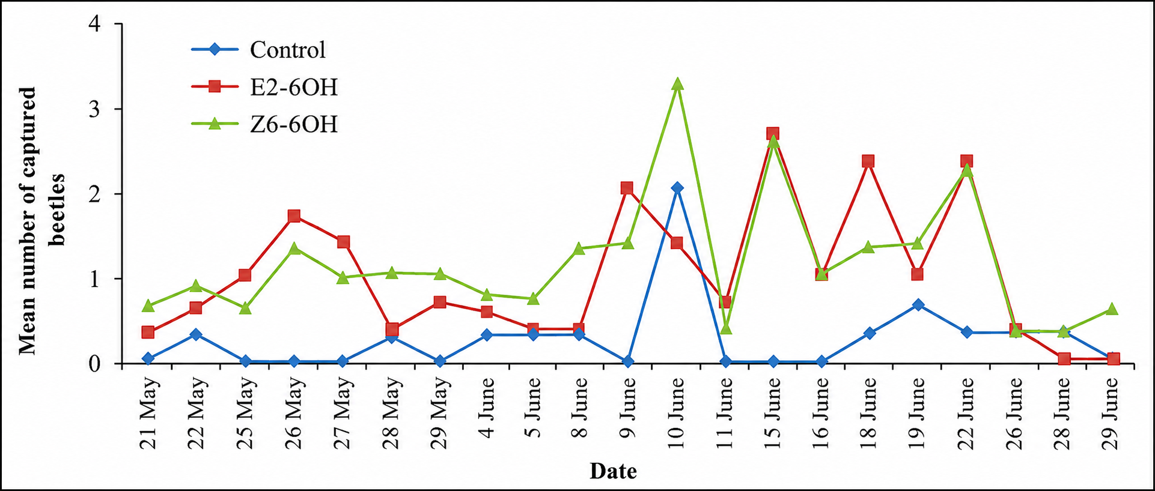
Fig. 5. Mean catches of adult Tanymecus dilaticollis in TAL sticky traps baited with single-component lures loaded into PE cotton dispensers and in unbaited control traps, Knezha, Bulgaria, 2009, three replicates.
During 2011, TAL sticky traps baited with the binary blend of E2-6OH and Z3-6OH (1:1) detected the onset of adult Tanymecus dilaticollis activity at the beginning of April. The highest trap catches were recorded between 20 and 25 April (Fig. 6). A second distinct peak in adult activity occurred from the second half of May to early June 2011. These peaks coincided with the early developmental stages of maize, from seedling emergence to the five-leaf stage, during which the grey maize weevil causes the greatest damage. The last adults of T. dilaticollis were captured on 8 July 2011. The seasonal activity pattern recorded in the unbaited control traps was generally similar; however, the activity peaks were much less pronounced. Nearly twice as many adults were captured in baited traps as in the unbaited control traps, and the difference in mean catches was statistically significant (P = 0.0026; t-test). In 2013, a distinct peak in adult activity of the grey maize weevil was observed from late April to early May, followed by a second, less pronounced peak after mid-May (Fig. 7).

Fig. 6. Mean catches (± SE) of adult Tanymecus dilaticollis in TAL sticky traps baited with the binary blend of E2-6OH and Z3-6OH (1:1) loaded into Just Plastics PE 2.5-ml containers, Knezha, Bulgaria, 2011, four replicates. The line represents the mean daily air temperature (°C). Arrows indicate the beginning and the end of the monitoring period, and X denotes the sampling date on which no catches were recorded because the traps had been destroyed by strong winds.

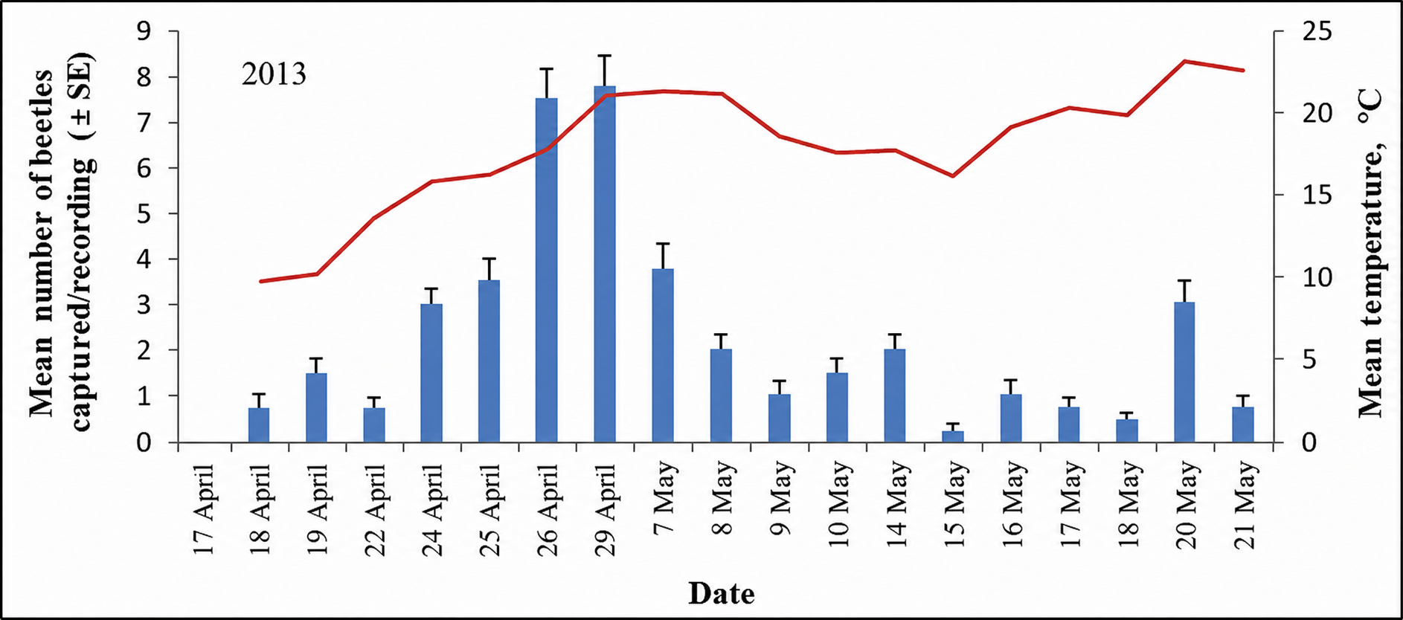
Fig. 7. Mean catches (± SE) of adult Tanymecus dilaticollis in TAL sticky traps baited with binary lures, Knezha, Bulgaria, 2013, four replicates.

4.1.5. Investigation of the attractiveness of live conspecifics in the field
When the attractiveness of live male and female individuals was investigated (placed in metal cages containing five individuals of each sex and supplemented with maize leaves), adult grey maize weevils were captured in all tested trap variants. The highest mean catch of male beetles was recorded in traps baited with live females. A statistically significant difference was found between the mean catches of males in traps baited with live females and those in the control traps (P ≤ 0.05, ANOVA, LSD test). In contrast, the highest mean catch of female T. dilaticollis individuals was recorded in traps baited with live males; however, no statistically significant differences were detected between catches in traps baited with live males and those in the other tested variants (live females and control traps).

4.1.6. Evaluation of the efficacy of the bioinsecticide Naturalis against Tanymecus dilaticollis under field conditions
The results of the field evaluation of Naturalis showed low mean mortality (0.12 ± 0.33) of the adults of the grey maize weevil in the control treatment (treated with tap water). The mean number of dead beetles in plots treated with both Naturalis application rates was significantly higher compared with the control, and these differences were statistically confirmed.
The occurrence of mycosis was confirmed by the presence of a white fungal growth on dead insects several days after their placement on moist filter paper in clean Petri dishes at room temperature. On the other hand, the highest number of live beetles was recorded in the control treatment; however, statistical analysis did not reveal significant differences in the mean number of surviving beetles between the control and the Naturalis treatment at the rate of 200 ml/da.

4.1.7. Effect of white oregano essential oil on adults of Tanymecus dilaticollis under laboratory conditions
In the experiment involving substrate treatment in Petri dishes, the mean mortality of experimental insects in the control treatment was 8%. In this experiment, 100% corrected mortality was observed within the first minutes after treatment with the highest essential oil concentration (10 µl/ml) (Fig. 8). The concentration of 1 µl/ml was also effective, with mean corrected mortality ranging from 82% on the first day of the experiment to 91% at the end of the observation period.
At the lowest tested concentrations, the effect of the essential oil was relatively weak, with mean corrected mortality reaching 15–16% at the end of the observation period. At the end of the experiment, the calculated LC50 value was 0.14 µl/ml (95% CI: 0.013–1.21 µl/ml), whereas the LC90 value was 0.83 µl/ml (95% CI: 0.09–7.43 µl/ml).

Fig. 8. Lethal effect of white oregano essential oil on adult Tanymecus dilaticollis at different concentrations in a Petri dish bioassay.
In the experiment involving individual insect treatment, the mean mortality in the control treatment was 5%. High insecticidal activity was observed only at the highest tested concentration, which resulted in 88% mortality at the end of the experiment (Fig. 9). It is important to note that mortality of the majority of insects in this treatment occurred within half an hour after application.
At the other tested concentrations, mortality remained low on the tenth day after treatment, reaching 17% at the concentration of 1 µl/ml and 9% at the two lowest concentrations. On the tenth day, the calculated LC₅₀ and LC₉₀ values were 1.14 µl/ml (95% CI: 0.022–49.35 µl/ml) and 16.42 µl/ml (95% CI: 0.38–713.71 µl/ml), respectively.

Fig. 9. Lethal effect of white oregano essential oil at different concentrations following direct topical application to individual adult Tanymecus dilaticollis, with insects maintained in mesh-covered containers.
In both experiments, the lowest mean lethal time (LT₅₀) was achieved at the two highest tested concentrations of essential oil. In the experiment involving treatment of filter paper in Petri dishes, the LT₅₀ value at a concentration of 1 µl/ml was reached after only 28 min, whereas in the experiment involving direct application to insects, the LT₅₀ value at the highest concentration (10 µl/ml) was 173 min.

4.1.8. Effect of white oregano essential oil on maize under laboratory conditions
Maize plants treated with the highest concentration of white oregano essential oil (100 μl/ml) exhibited pronounced phytotoxic symptoms. Approximately 3 hours after treatment, browning of the leaves was observed, and by the fourth day of observation all plants had completely died. Following treatment with the 10 μl/ml concentration of essential oil, slight damage symptoms were observed in 66% of the plants during the first three days (score 1). However, by the fourth day the plants had fully recovered and showed no further signs of phytotoxicity, with normal development similar to plants treated with distilled water. During the ten-day observation period, no phytotoxic symptoms were detected in maize plants treated with essential oil concentrations of 0.1 μl/ml and 1 μl/ml, as well as in the control treatments (distilled water, distilled water with Tween) and the Mospilan 20 SP treatment.

4.1.9. Effect of white oregano essential oil on maize under field conditions
Under field conditions, maize plants in the control treatments did not exhibit any symptoms of phytotoxic effects during the ten-day observation period. Leaves of plants treated with the 100 μl/ml concentration showed browning approximately 6 hours after essential oil application; however, they gradually recovered and by the eighth day of observation showed no visible damage symptoms and developed similarly to plants in the control treatments. Mild phytotoxic symptoms were also recorded at the 10 μl/ml concentration, but the plants fully recovered by the third day. In all other treatments, plants remained healthy and developed normally.

4.1.10. Effect of entomopathogenic nematode products under field conditions
Open-field experiments: A significant difference was established between the mean number of weevils in plots with seeds treated with Gaucho 600 FS/Nemastar® and those with biologically treated seeds, either with or without entomopathogenic nematodes. After the second nematode application, the analysis did not show significant differences in adult abundance (Kruskal–Wallis test, P = 0.07). The total number of dead adult T. dilaticollis individuals was 34, with 62% found in plots with seeds treated with Gaucho 600 FS and subsequently treated with Nemastar®, followed by 26% in plots with seeds treated with Naturalis and treated with Nemastar®. Only two dead specimens were found in each control plot. After the second nematode application, during the period 19 May–3 June 2022, a total of 69 live and 10 dead adult grey maize weevils were recorded. The number of live weevils was similar (11–12 individuals; 0.4–0.5 weevils/m²), regardless of the seed treatment type. Dead weevils were recorded only in plots treated with S. carpocapsae - 40% in plots with biological seed treatment and 60% in plots with chemical seed treatment. Entomopathogenic nematodes were detected only in single dead specimens collected from nematode-treated plots on 16, 20 and 23 May 2022.
Semi-field experiments in cages (isolators): In semi-field tests, the number of surviving weevils varied, but the mean number was similar regardless of treatment. After the first application, only individual dead specimens were observed. In cages treated with Nemastar®, dead adults appeared from the first day, whereas in control cages only two dead specimens were recorded, on 12 and 16 May 2022, respectively. In the second experiment, the number of live T. dilaticollis individuals decreased over time—from 14–18 individuals at the beginning of the experiment (20 May 2022) to 1–6 weevils at the end of the observation period (10 June 2022). Mortality of experimental individuals in cages treated with Nemastar® was low -14% in Experiment 1 and 18% in Experiment 2 but higher than in the control cages (2% and 1%). Mortality was slightly higher in cages with chemically treated seeds. Entomopathogenic nematodes were detected only in dead specimens from treated cages. In Experiment 2, the number of dead weevils was more than four times higher compared with Experiment 1, probably due to higher humidity and greater insect density.

Experiment with Nematop® Käfer-Stopp traps: The mean number of live and dead T. dilaticollis individuals within a 5 m radius around traps containing gel with infective juveniles of S. carpocapsae was relatively low, with no significant differences between treatments in areas with different seed treatment practices (P = 0.764 for live individuals; P = 0.321 for dead individuals). Following dissections of the dead weevils collected, nematodes were detected in only one dead specimen.

4.1.11. Discussion of the results for Tanymecus dilaticollis
Although T. dilaticollis is an economically important polyphagous pest in Eastern Europe, its chemical ecology has remained largely unexplored. For the first time, through a combination of methods, including behavioural field tests of candidate plant attractants using traps at the Maize Research Institute in Knezha, two synthetic plant-derived compounds attracting adults of this pest were identified (Toshova et al., 2010; El-Sayed, 2026). (E)-2-hexen-1-ol (E2-6OH) and (Z)-3-hexen-1-ol (Z3-6OH) attracted both sexes under field conditions; therefore, we consider that these compounds function as food attractants. The ratio of the volatile compounds Z3-6OH and E2-6OH in the lure did not influence the catches of T. dilaticollis.
In this study, the efficiency of three types of dispensers containing the same chemical components was compared. According to the results, the Just Plastics PE container (2.5 ml) dispenser showed higher efficiency compared with Kartell PE vials (1 ml) and PE cotton dispensers. The activity of the kairomonal attractant was also influenced by trap parameters. The selection of trap designs for comparison, placed either on the soil surface or partially buried in the soil, was based on the behavioural characteristics of the grey maize weevil, which mainly moves by walking on the soil surface or on vegetation. Our results demonstrated that TAL sticky traps (modified pitfall-type traps with a roof and ramp) were the most suitable for capturing adult T. dilaticollis compared with cotton boll weevil traps, Yatlor funnel traps (highly effective for capturing adult click beetles), and round pitfall traps equipped with a funnel and roof.
The results obtained in 2011 using TAL traps with a sticky surface at the bottom and lures containing Z3-6OH and E2-6OH (1:1) (applied on Just Plastics dispensers and replaced every 3–4 weeks) showed that overwintered adults of T. dilaticollis are active from early April until early July. This allows us to conclude that these lures can be used as a monitoring tool for adult activity of the grey maize weevil.
The preliminary results from the field evaluation of Naturalis, tested at two rates (100 ml/da and 200 ml/da), indicate that the higher dose and repeated application significantly contribute to its efficacy. These findings, together with previous laboratory results (Toshova et al., 2021), provide a basis for further studies aimed at confirming the high effectiveness of this bioinsecticide against T. dilaticollis in maize crops.
Based on laboratory experiments with white oregano essential oil, we established that only the highest concentrations exhibited strong insecticidal activity against adults of T. dilaticollis: 1 µl/ml and 10 µl/ml in the experiment involving filter paper treatment in Petri dishes, and 10 µl/ml in the experiment involving direct application of the plant extract onto insects. The highest tested concentration (10 µl/ml) caused extremely rapid mortality, with 100% mortality observed within the first minutes after exposure in the substrate treatment experiment. These results indicate that essential oil has a strong contact and probably fumigant effect on the insects.
In conclusion, white oregano EO demonstrates considerable potential for use in biological plant protection against T. dilaticollis. However, further studies are needed to determine optimal doses, application methods, and efficacy under field conditions.
White oregano EO at concentrations up to 10 μl/ml is suitable for further investigation as a bioinsecticide against adult grey maize weevils in maize crops, as the risk of permanent phytotoxic damage to maize under field conditions is minimal. On the other hand, to increase the practical applicability of essential oils in agriculture, the development of appropriate formulation strategies is necessary.
The results from field experiments with Nemastar® in open maize fields showed that: 1) The population density of the grey maize weevil was relatively low during the study period; 2) The mean number of live weevils was significantly lower in plots with Gaucho-treated seeds compared with biologically treated plots; 3) The mean number of dead adult T. dilaticollis individuals was higher in Nemastar®-treated plots than in control treatments where no entomopathogenic nematode product was applied and 4) Entomopathogenic nematodes were detected only in microscopic preparations from dead adult T. dilaticollis individuals collected from Nemastar® treatments.
The present study is the first report of entomopathogenic nematodes associated with the grey maize weevil. The absence of entomopathogenic nematodes in control treatments indicates the lack of established local populations of S. carpocapsae and the absence of dispersal from treated areas.

4.2. Diabrotica virgifera virgifera

4.2.1. Monitoring of the seasonal activity of Diabrotica virgifera virgifera adults using coloured sticky traps without lures
Despite the early placement of traps in the field at the beginning of June 2014, a total of 21 adult D. v. virgifera individuals were recorded only during the period from 22 July to 17 September 2014 (Fig. 10). Captures were registered in all trap variants except the red sticky traps (Fig. 11).

Fig. 10. Seasonal activity of adult Diabrotica virgifera virgifera at the Experimental Centre in Knezha, Bulgaria, 2014.
The highest mean number of beetles was captured in the fluorescent yellow sticky traps however, no statistically significant differences were detected among the mean catches in the tested variants.

Fig. 11. Distribution of mean catches of adult Diabrotica virgifera virgifera in transparent and colored sticky traps (white, blue, orange, yellow, and fluorescent yellow) in 2014.

4.2.2. Monitoring of the seasonal activity of Diabrotica virgifera virgifera adults using KLP+ traps with pheromone and plant lures
In 2015, despite the timely deployment of traps in the field in mid-June and regular replacement of lures, the first captures of D. v. virgifera were recorded only during the period 22–24 July 2015 (Fig. 12). The highest mean catch was observed at the end of July, while the last captures occurred between 5 and 12 August 2015. In 2016, the first appearance of adults was recorded between 23 and 25 July (Fig. 13). The western corn rootworm was most abundant at the end of July and the beginning of August. In 2016, adult captures were recorded until early September.
A relatively high population density of adult western corn rootworm at the experimental field in Knezha was recorded in 2016, with total trap catches approximately 60 times higher than those observed in 2015.

Fig. 12. Seasonal activity of adult individuals of D. v. virgifera in 2015, determined using KLP+ traps equipped with a dual lure (pheromone and floral lure). Arrows indicate the dates of the beginning and end of the study period.

Fig. 13. Seasonal activity of adult individuals of D. v. virgifera in 2016.

4.2.3. Effect of yellow colour hue of the trap in combination with pheromone and plant lures

In 2017 and 2018, no statistically significant differences were found between catches in yellow and fluorescent yellow KLP+ traps baited with pheromone and plant lures at the same trap height. In 2017, higher catches were recorded in yellow traps, whereas in 2018 when the population density of D. v. virgifera was relatively higher beetles were more abundant in fluorescent yellow traps.

4.2.4. Monitoring of the seasonal activity of Diabrotica virgifera virgifera adults in maize crops with different seed treatments (biological and chemical)
In 2022, similar abundances of adult D. v. virgifera were recorded in maize fields with different seed treatments throughout the study period. The onset of flight activity was missed. Captures were recorded from late June to early September, with peak abundance occurring in July.

4.2.5. Effect of white oregano EO on D. v. virgifera adults in the laboratory
At the end of the laboratory experiments, mean mortality in the control groups reached 12% (SE ± 2%) in the experiment with pure essential oil and 18% (SE ± 3%) in the experiment with essential oil dissolved in 0.01% Tween 80.
In the first experiment, all treatments with undiluted essential oil (3 µl, 5 µl, and 10 µl) induced high mortality in adult D. v. virgifera, reaching 98–100% within 10 days. At the highest dose (10 µl), 100% mortality was achieved as early as the second day after treatment, while at 5 µl all insects died by day seven. Statistically significant differences were detected in mortality depending on oil dose (F_{2,90} = 26.35; P < 0.001), exposure time (F_{9,90} = 31.43; P < 0.001), and their interaction (F_{18,90} = 7.07; P < 0.001). LT₅₀ decreased with increasing oil dose, ranging from several hours (mean 6.86 h; 95% CIs: 3.14–13.81 h) to a few minutes after exposure (mean 8.39 min; 95% CIs: 2.27–24.00 min). Results from assays with diluted essential oil showed that the highest concentration (10 µl/ml) caused 100% mortality of adult western corn rootworm within three days, while 92% mortality was achieved after nine days at 1 µl/ml. Two-way ANOVA revealed significant effects of essential oil concentration (F_{3,120} = 157.77; P < 0.001), exposure time (F_{9,120} = 17.29; P < 0.001), and their interaction (F_{27,120} = 3.93; P < 0.001) on insect mortality. After 24 h of exposure, LC₅₀ and LC₉₀ values were 0.62 µl/ml (95% CIs: 0.06–6.29 µl/ml) and 5.77 µl/ml (95% CIs: 0.57–58.44 µl/ml), respectively. Ten days after treatment, these values decreased to 0.36 µl/ml (95% CIs: 0.09–1.40 µl/ml) for LC₅₀ and 0.03 µl/ml (95% CIs: 0.01–0.10 µl/ml) for LC₉₀. The mean lethal time (LT₅₀) decreased with increasing essential oil concentration. In our experiments, the time required for the oil solutions to induce LT₅₀ in D. v. virgifera ranged from 17.95 days (95% CI: 10.05–35.15 days) at the lowest concentration (0.01 µl/ml) to 90 min (95% CIs: 36–193 min) at the highest concentration (10 µl/ml).
4.2.6. Evaluation of the lethal effect of a Metarhizium pemphigi strain on adult individuals of Diabrotica virgifera virgifera under laboratory conditions
At the end of the laboratory experiment with M. pemphigi in Petri dishes, the mean mortality of adult D. v. virgifera individuals in the control group reached 10% (SE: ±1%). All tested conidial concentrations of M. pemphigi showed pathogenicity against adults of the western corn rootworm under laboratory conditions. Dead insects from treatments with M. pemphigi conidia exhibited green discoloration, which is a typical symptom of Metarhizium infection (fungi of this genus are known to cause green muscardine disease). This represents the first confirmed observation of pathogenicity of this fungal species against D. v. virgifera.
Mortality of D. v. virgifera resulting from M. pemphigi infection increased with increasing conidial concentration and exposure time. No dead insects showing symptoms of mycosis were recorded in the control group. Mean mortality of western corn rootworm adults ranged from 3% to 50% at conidial concentrations from 2 × 10³ conidia/ml to 2 × 10⁷ conidia/ml seven days after treatment. The maximum mortality of adult D. v. virgifera reached 73% ten days after treatment with the highest concentration of the conidial suspension (2 × 10⁷ conidia/ml). Mortality at the intermediate concentration (2 × 10⁵ conidia/ml) was 33% during the same period.
The conidial concentration causing LC₅₀ for the adults of the western corn rootworm after ten days was 3.3 × 10⁶ conidia/ml (95% CIs: 1.4 × 10⁵ – 1.0 × 10⁷ conidia/ml), whereas LC₉₀ was 5.1 × 10⁸ conidia/ml (95% CIs: 9.1 × 10⁷ – 1.5 × 10¹⁰ conidia/ml). Mean lethal time (LT₅₀) values ranged from 25.86 days to 7.19 days for the lowest and highest tested concentrations, respectively.

4.2.7. Discussion of the results for Diabrotica virgifera virgifera
This study represents the first evaluation in Bulgaria of the effectiveness of KLP+ traps combined with two types of lures – pheromone and floral lure. This type of trap is characterized by a large collecting container and ease of use. The combination of two lures increases trap efficiency. The results obtained from our studies on the effect of sticky PAL trap colour and the shade of yellow colour of KLP+ traps confirm the findings of Tóth et al. (2003), according to which fluorescent yellow PAL sticky traps capture a higher mean number of D. v. virgifera beetles compared with traps of other colours without lures, although no statistically significant differences were established among the tested variants. The obtained results demonstrate the potential application of Csalomon® KLP+ traps equipped with pheromone and floral lures in monitoring systems in Bulgaria for detection of adult emergence and assessment of adult flight dynamics. The results of the conducted experiments showed that essential oil (EO) from white oregano is highly effective against adult individuals of D. v. virgifera.
The findings of the present study indicate that both pure white oregano EO applied at quantities of 3–10 µl and its solutions at concentrations above 1 µl/ml (0.1%) cause very high mortality in adults of D. v. virgifera – over 98% in experiments with pure oil and over 92% in experiments with emulsions. The observed high insecticidal activity of white oregano EO against adults of D. v. virgifera under laboratory conditions provides sufficient justification for further investigations. The obtained results represent a solid basis for the potential use of white oregano EO as a botanical insecticide within IPM programmes for the control of western corn rootworm. The results of the laboratory experiment with the entomopathogenic fungus showed that the M. pemphigi strain AMEP28 can infect and cause lethal effects in adult individuals of western corn rootworm. However, only the highest concentration of the conidial suspension (2 × 10⁷ conidia/ml) caused a high mortality rate (73%) after an exposure period of 10 days.
4.3. Oulema melanopus

4.3.1. Evaluation of the efficacy of the bioinsecticide Naturalis against adults of Oulema melanopus under laboratory conditions
In the experiment involving the treatment of adult O. melanopus individuals with Naturalis in Petri dishes, the mean mortality of the experimental insects in the control treatment was 17% (SE: ± 2). During the study period (10 days), the bioinsecticide Naturalis (B. bassiana), tested at six concentrations (2.3 × 10² – 2.3 × 10⁷ conidia/ml distilled water containing 0.01% Tween 80), caused high mortality in adult O. melanopus under laboratory conditions at the two highest concentrations, 2.3 × 10⁶ conidia/ml and 2.3 × 10⁷ conidia/ml, resulting in 86% and 93% corrected mortality compared with the control, respectively (Fig. 14). The lethal effect increased with increasing concentration of the product. The effects of concentration (F_{(5,180)} = 63.88; P < 0.001) and exposure time (F_{(9,180)} = 23.23; P < 0.001) on mortality of adults were statistically significant. A statistically significant interaction between concentration and exposure time was also observed (F_{(45,180)} = 1.57; P = 0.029). Differences in mortality levels among adult O. melanopus treated with different conidial concentrations were significant (F_{(5,18)} = 7.42; P = 0.003). High mortality levels (> 88%) were observed only at the two highest conidial concentrations, 2.3 × 10⁶ and 2.3 × 10⁷ conidia/ml, which differed significantly from the mean mortality caused by concentrations ranging from 2.3 × 10² to 2.3 × 10⁴ conidia/ml (ANOVA followed by LSD test; P < 0.05). The conidial suspension concentrations causing LC₅₀ and LC₉₀ mortality in adult O. melanopus were 8.3 × 10⁴ conidia/ml (95% CIs: 1.1 × 10⁴ – 9.1 × 10⁵ conidia/ml) and 8.2 × 10⁶ conidia/ml (95% CIs: 7.5 × 10⁵ – 8.9 × 10⁷ conidia/ml), respectively.

Fig. 14. Cumulative mortality (%) of adult Oulema melanopus treated with different concentrations of B. bassiana (2.3 × 10² – 2.3 × 10⁷ conidia/ml).
Insect fungal mycelium was observed only on the carcasses of adult cereal leaf beetles treated with B. bassiana. Only 2% of the dead adults in the Naturalis variants were without white mycelium. At the lowest fungal concentration, 11% of the dead adults showed the presence of white mycelium. The highest percentage of dead adults exhibiting mycosis was recorded at the highest tested concentration. LT₅₀ values ranged from 26 days at the lowest concentration to two days at the highest concentration of conidia of the product.

4.3.2. Evaluation of the efficacy of the bioinsecticide Naturalis against larvae of Oulema melanopus under laboratory conditions

The mean mortality of O. melanopus larvae in the control treatment was 26.7% (SE: ± 1.7%). The mean mortality percentage of larvae treated with Naturalis was concentration-dependent and increased with increasing conidial concentration and exposure time. At the end of the experiment, high corrected mortality (>95%) was observed in larvae treated with all tested suspensions (Fig. 15). Larvae of O. melanopus treated with the highest concentration died within 24 hours after exposure. Analysis of variance regarding the concentration of B. bassiana (F_{(5,180)} = 55.66; P < 0.001), exposure duration (F_{(9,180)} = 218.74; P < 0.001), and their interaction (F_{(45,180)} = 10.65; P < 0.001) showed highly significant effects on the mortality levels of O. melanopus larvae. The conidial concentration causing LC₅₀ mortality in O. melanopus larvae after 10 days was 4.6 conidia/ml (95% CIs: 0.09 – 1.1 × 10⁴ conidia/ml), while the LC₉₀ value was 6.2 × 10² conidia/ml (95% CIs: 0.26 – 1.5 × 10⁶ conidia/ml). The LT₅₀ values ranged from two to four days for concentrations of 2.3 × 10² to 2.3 × 10⁶ conidia/ml. Infected larvae showed 100% whitening, which is a clear symptom of fungal pathogen development (mycosis). This confirms that mortality resulted from the activity of the product regardless of concentration, whereas no signs of mycelial growth were observed in dead individuals from the control group.

Fig. 15. Cumulative mortality (%) of Oulema melanopus larvae treated with different concentrations of B. bassiana (2.3 × 10² – 2.3 × 10⁷ conidia/ml).

4.3.2. Discussion of the results for Oulema melanopus
This is the first study describing the susceptibility of different developmental stages of this species to different concentrations of the commercial strain B. bassiana ATCC 74040. The results of the present study demonstrate that O. melanopus larvae are highly susceptible to Naturalis, with cumulative mortality exceeding 96% over a wide range of concentrations (2.3 × 10² – 2.3 × 10⁷ conidia/ml). High mortality of adult O. melanopus individuals was observed only at the highest concentrations of the product. In summary, the comparative results clearly demonstrate that the efficacy of Naturalis is strongly host-dependent, with a distinct gradient of susceptibility among adult individuals of the studied coleopteran species under laboratory conditions: T. dilaticollis > D. v. virgifera > O. melanopus (Toshova et al., 2021; Velchev et al., 2023). This finding highlights that laboratory-determined virulence does not necessarily ensure equally effective control under field conditions among different target species.

Conclusions
The present study provides new data on the ecology, monitoring of seasonal activity of adults, and the potential of biological control methods against three important maize pests in Bulgaria: the grey corn weevil (Tanymecus dilaticollis), the western corn rootworm (Diabrotica virgifera virgifera), and the cereal leaf beetle (Oulema melanopus).
The results support the proposed research hypotheses.

Tanymecus dilaticollis:
- Field trials evaluating the activity of synthetic plant-derived compounds using traps identified two attractants for both female and male adults of the grey corn weevil: (E)-2-hexen-1-ol (E2-6OH) and (Z)-3-hexen-1-ol (Z3-6OH), whereas (Z)-3-hexenyl butyrate exhibited a repellent effect.
- The binary blend of E2-6OH and Z3-6OH at a 1:1 ratio significantly increased adult captures of both sexes compared with their individual application or the control treatments.
- When combined with identical plant-derived lures, TAL sticky traps (CSALOMON®) showed the highest efficiency and outperformed other trap types (Yatlor funnel, Cone, and Pitfall traps). Using traps equipped with synthetic plant lures, the seasonal activity of overwintered adults was shown to extend from early April to early July, with the highest relative abundance recorded during the early phenological stages of maize (from emergence to the 5–7 leaf stage).
- In field conditions, TAL sticky traps demonstrated intraspecific attraction between male and female individuals.
- In field trials, the bioinsecticide Naturalis (Beauveria bassiana strain ATCC 74040) achieved satisfactory efficacy (up to approximately 52% after the second application) when applied at higher doses and after repeated treatments.
- Treatments of maize areas (open-field plots and cage experiments) with Nemastar® (a commercial product containing entomopathogenic nematodes of Steinernema carpocapsae) (e-nema GmbH) increased the number of dead weevils regardless of the type of seed treatment before sowing (biological or chemical). The results indicate a potential contribution to increased maize yield.
- Essential oil (EO) from Greek oregano (Origanum vulgare subsp. hirtum) exhibited strong contact and probable fumigant activity under laboratory conditions at concentrations of 1–10 µl/ml (aqueous solutions containing 0.01% Tween emulsifier).

Diabrotica virgifera virgifera:
- High efficiency of KLP+ traps (CSALOMON®) equipped with a dual lure (synthetic sex pheromone and plant attractant) was demonstrated for attracting adults of the western corn rootworm and monitoring its seasonal activity in Bulgaria.
- The shade of yellow colour of KLP+ traps equipped with semiochemical lures did not influence beetle behaviour.
- The seasonal activity of D. v. virgifera in the Kneja region extends from late June to early September. Under laboratory conditions, pure EO from Greek oregano demonstrated extremely high insecticidal activity and a rapid lethal effect against adults of the western corn rootworm, whereas emulsions in distilled water were effective only at the highest tested concentrations: 1 µl/ml (92% corrected mortality of experimental insects) and 10 µl/ml (100% corrected mortality of experimental insects).
- Laboratory studies demonstrated that the entomopathogenic fungus Metarhizium pemphigi (strain AMEP28) is pathogenic to adult individuals under laboratory conditions, causing up to 73% mortality at the highest concentration after 10 days.

Oulema melanopus:
- The bioinsecticide Naturalis (B. bassiana) demonstrated high insecticidal activity under laboratory conditions against both adults (up to 93% corrected mortality at the highest tested concentrations) and, particularly, larvae (over 95% corrected mortality) at all tested concentrations, with a rapid lethal effect. At the end of the experiment, high corrected mortality (>95%) of larvae was observed for all tested product suspensions.

Zea mays:
- Under laboratory conditions, a clear phytotoxic effect of Greek oregano EO on young maize plants, expressed as leaf browning and plant death, was observed only after treatment with emulsions at a concentration of 100 µl/ml.
- Under field conditions, young maize plants treated with Greek oregano EO at concentrations ranging from 0.1 to 100 µl/ml did not show symptoms of phytotoxicity at the end of the observation period.

Contributions

Scientific contributions
- For the first time, attractants for the grey corn weevil were identified: E2-6OH and Z3-6OH, as well as their 1:1 binary blend. These compounds function as food attractants (kairomones).
- The composition of the lure, the type of dispenser, and the trap design were demonstrated to be important factors influencing the captures of adult T. dilaticollis individuals under field conditions.
- For the first time, data on sex pheromone communication in the grey corn weevil were obtained.
- For the first time in Bulgaria, new data on the seasonal flight dynamics of D. v. virgifera were obtained using KLP+ traps equipped with a dual lure (sex pheromone + plant attractant).
- For the first time, the insecticidal effect of Naturalis was demonstrated under field conditions against T. dilaticollis and under laboratory conditions against O. melanopus. Larvae of the cereal leaf beetle were more susceptible than adults of the same species to the action of the entomopathogenic fungus B. bassiana strain ATCC 74040.
- New data were obtained on the pathogenicity of Metarhizium pemphigi (strain AMEP28) against adults of D. v. virgifera.
- For the first time in Bulgaria, nematode-based products containing entomopathogenic nematodes of the species Steinernema carpocapsae were tested against T. dilaticollis: the powder formulation Nemastar® under semi-field and field conditions and Nematop Käfer-Stopp trap® (e-nema GmbH, Germany) under field conditions. Nematode infections were confirmed in dead pest individuals as a result of these investigations.
- For the first time, the biological activity of essential oil from Greek oregano was evaluated against adults of T. dilaticollis and D. v. virgifera under laboratory conditions. The oil demonstrated toxic effects against both species, with the western corn rootworm showing higher sensitivity to the tested emulsions.

Scientific and applied contributions
- TAL sticky traps (Csalomon®, Hungary), equipped with a two-component lure consisting of E2-6OH and Z3-6OH in a 1:1 ratio, applied to polyethylene container-type dispensers with caps and a volume of 2.5 ml (Just Plastics Ltd., UK), are an appropriate tool for monitoring the seasonal activity of adult individuals of T. dilaticollis. This lure also attracts adults of the pest species black beet weevil, Psallidium maxillosum. To obtain more accurate data, regular recording of trap catches and replacement of the sticky surfaces (2–3 times per week), as well as periodic replacement of the semiochemical lure at intervals of 3–4 weeks, are necessary.
- Nemastar® is suitable for application against adults of the grey corn weevil in biological and integrated production systems at a rate of 5 billion nematodes/ha, provided that the conditions of use specified by the manufacturer are strictly followed.
- KLP+ traps combined with a dual lure (sex pheromone + plant attractant) represent a suitable tool for surveying and monitoring the seasonal flight dynamics of D. v. virgifera.
The results of this dissertation may serve as a basis for future research aimed at developing practical recommendations and new biorational products and strategies under conditions of increasing restrictions on neonicotinoids and growing demands for environmentally friendly agriculture.

List of references
Angelov P. A. (1978). Fauna of Bulgaria, vol. 7. Coleoptera, Curculionidae. II part. Brachyderinae, Brachycerinae, Tanymecinae, Cleoninae, Myorrhininae. Bulgarian Academy of Sciences, Sofia, 234 pp. (in Bulgarian)
Angelov P. A. (1980). Fauna of Bulgaria, vol. 10. Coleoptera, Curculionidae. IV part. Calandrinae. 2. Bulgarian Academy of Sciences, Sofia, 301 pp. (in Bulgarian)
BFSA. (2017). Order No. RD 11-536/21.03.2017 on setting economic injury thresholds for economically important pests of agricultural crops. Sofia, Executive Director of BFSA.
Directive 2009/128/EC of the European Parliament and of the Council of 21 October 2009 establishing a framework for Community action to achieve the sustainable use of pesticides. (in Bulgarian)
El-Sayed, A. M. (2026). The Pherobase: Database of Pheromones and Semiochemicals. http://www.pherobase.com. [10.01.2026]
Genov, N., Mitrović, J., Genov, M., Duduk, B. (2014). First report of corn reddening caused by 'Candidatus Phytoplasma solani' in Bulgaria. Plant Disease, 98 (7): 991.
Goodman, M. M., Galinat, W. C. (1988). The history and evolution of Maize. Critical Reviews in Plant Sciences, 7 (3): 197–220.
Gruev, B., Tomov, V. (1986). Fauna of Bulgaria, Vol. 16: Coleoptera, Chrysomelidae. Part 2. Bulgarian Academy of Sciences, Sofia,, 388 pp. (in Bulgarian)
Hoxie, R. P., Wellso, S. G. (1974). Cereal leaf beetle instars and sex, defined by larval head capsule widths. Annals of the Entomological Society of America, 67 (2): 183–186.
Ivanova, I. (2002a). The first occurrence of Diabrotica virgifera virgifera in Bulgaria. Acta Phytopathologica et Entomologica Hungarica, 37 (1–3): 155–157.
Machado, A. B., Silva, J. R., Oliveira, M. P. (2024). Phytotoxicity and growth of crop plants under different herbicide treatments. Journal of Agricultural Science, 16 (2): 45–58.
Ranum, P., Peña-Rosas, J. P., Garcia-Casal, M. N. (2014). Global maize production, utilization, and consumption. Annals of the New York Academy of Sciences, 1312 (1): 105–112.
Regulation (EC) No 1107/2009 of the European Parliament and of the Council of 21 October 2009 concerning the placing of plant protection products on the market and repealing Council Directives 79/117/EEC and 91/414/EEC. (in Bulgarian)
Shiferaw, B., Prasanna, B. M., Hellin, J., Bänziger, M. (2011). Crops that feed the world 6. Past successes and future challenges to the role played by maize in global food security. Food Security, 3 (3): 307–327.
Simov, N. (2016). The invasive brown marmorated stink bug Halyomorpha halys (Stål, 1855) (Heteroptera: Pentatomidae) already in Bulgaria. Ecologica Montenegrina, 9: 51–53.
Szanyi, S., Barta, M., Velchev, D., Beshkov, S., Mumford, S., Todorov, I., Nagy, A., Varga, Z., Tóth, M., Toshova, T. (2025). First Report of a Migratory Pest, the Fall Armyworm, Spodoptera frugiperda (J. E. Smith, 1797) (Lepidoptera, Noctuidae) from Bulgaria. Insects, 16 (2): 134.
Tomov, Т., Yordanov, Y. (1988). Maize in Bulgaria. Zamizdat, Sofia, 315 pp. (in Bulgarian)
Toshova, T., Velchev, D., Pilarska, D., Todorov, I., Draganova, S., Holuša, J., Takov, D. (2021). Effect of bioinsecticides on the grey maize weevil Tanymecus dilaticollis. Plant Protection Science, 57 (3): 240–247.
Tóth, M., Sivcev, I., Ujvary, I., Tomasek, I., Imrei, Z., Horvath, P., Szarukan, I. (2003). Development of trapping tools for detection and monitoring of Diabrotica virgifera virgifera in Europe. Acta Phytopathologica et Entomologica Hungarica, 38: 307–322
Velchev, D. I., Takov, D. I., Todorov, I. A., Pilarska, D. K., Toshova, T. B. 2023. Effect of Beauveria bassiana (strain ATCC 74040) on two leaf beetle (Coleoptera: Chrysomelidae) pests of maize under laboratory conditions. Journal of Central European Agriculture, 24, 2: 434-446.

List of Scientific Publications Related to the Dissertation

1. Toshova, T. B., Velchev, D. I. 2012. Field attraction of two polyphagous weevil (Curculionidae: Entiminae) pests to the same synthetic floral lure in Bulgaria. Acta Еntomologica Bulgarica, 15, 1/2: 100-106.
2. Velchev, D., Toshova, T., Todorov, I., Beshkov, S., Kalushkov, P., Tóth, M. 2019. Effect of the hue of yellow colour on Diabrotica virgifera virgifera LeConte captures in KLP+ traps baited with dual lures. Journal of Mountain Agriculture on the Balkans (ISSN 1311-0489), 22, 6: 140-150.
3. Toshova, T., Velchev, D., Barta, M., Takov, D., Todorov, I., Pilarska, D., Tóth, M., Berkov, S., Nikolova, M. 2022. Insecticide activity of Greek oregano essential oil and entomopathogenic fungus Metarhizium pemphigi against Diabrotica virgifera virgifera LeConte. Cereal Research Communications (издателство Springer Nature): 50, 4: 1045-1054. ISSN:01333720, DOI:10.1007/s42976-022-00266-1; SJR (Scopus):0.336, JCR-IF (Web of Science):1.6 Q2 (Scopus)
Citations excluding self-citations: 2
4. Тakov, D., Toshova, T., Pilarska, D., Velchev, D. 2023. Entomopathogens of three beetle species with agricultural importance (Tanymecus dilaticollis, Oulema melanopus and Diabrotica virgifera virgifera): a review. North-Western Journal of Zoology (ISSN:1584-9074), 19, 2: 201-208. SJR (Scopus):0.259, JCR-IF (Web of Science):0.7 Q3 (Scopus)
5. Velchev, D. I., Takov, D. I., Todorov, I. A., Pilarska, D. K., Toshova, T. B. 2023. Effect of Beauveria bassiana (strain ATCC 74040) on two leaf beetle (Coleoptera: Chrysomelidae) pests of maize under laboratory conditions. Journal of Central European Agriculture, 24, 2: 434-446. ISSN:13329049, DOI:10.5513/JCEA01/24.2.3787; SJR (Scopus):0.208, JCR-IF (Web of Science):0.7 Q3 (Scopus)
Citations excluding self-citations: 3
6. Toshova, T. B., Velchev, D. I., Pilarska, D. K., Todorov, I. A., Esteves, I., Barth, M., Takov, D. I. 2024. Biocontrol potential of entomopathogenic nematodes against the grey maize weevil Tanymecus dilaticollis (Coleoptera: Curculionidae) adults. Biologia Futura (издателство Springer Nature), 75: 219-233. ISSN:2676-8607, DOI:10.1007/s42977-024-00206-6; SJR (Scopus):0.428, JCR-IF (Web of Science):1.8 Q2 (Scopus)
Citations excluding self-citations: 4
Acknowledgements
I would like to express my deepest gratitude to my supervisors – Prof. Dr. Olya Karadzhova (Institute of Soil Science, Agrotechnologies and Plant Protection “Nikola Pushkarov” – Agricultural Academy) and Assoc. Prof. Dr. Teodora Toshova (Institute of Biodiversity and Ecosystem Research – Bulgarian Academy of Sciences).
I am grateful to Prof. Karadzhova for her high scientific standards, methodological guidance, and for the opportunity to benefit from her extensive experience in the field of plant protection. Her support and professionalism were essential for the successful structuring and completion of this research.
I owe special thanks to Assoc. Prof. Dr. Teodora Toshova for her exceptional precision, guidance throughout the experimental work, and critical evaluation of the results. Her dedication and academic integrity were a strong stimulus for my development as a researcher.
I would like to thank the management and staff of the Maize Research Institute, Knezhа, for providing the facilities and favourable working environment that made this research possible. I sincerely appreciate the assistance of Silvia Terziyska for her technical support during the field experiments with traps for the grey corn weevil.
I am grateful to all colleagues from the Plant Protection Department at the Institute of Soil Science, Agrotechnologies and Plant Protection “Nikola Pushkarov” for their support, advice, and constructive comments.
I would also like to thank my colleagues from the Institute of Biodiversity and Ecosystem Research – Bulgarian Academy of Sciences for the fruitful collaboration.

Possibilities for the application of biological means for monitoring and control
of insect pests in maize

Dimatar Ivanov Velchev

Summary

The present dissertation presents the results of studies related to chemical ecology, monitoring of seasonal activity, and the possibilities for biological control of three important maize pests in Bulgaria – the grey maize weevil (Tanymecus dilaticollis), the western corn rootworm (Diabrotica virgifera virgifera), and the cereal leaf beetle (Oulema melanopus).
As a result of the conducted studies on Tanymecus dilaticollis, the synthetic plant compounds (E)-2-hexen-1-ol and (Z)-3-hexen-1-ol were identified for the first time as attractants acting as kairomones (plant attractants) for both sexes of this species. Among several lure variants tested, the highest efficacy was recorded for the binary blend applied in a 1:1 ratio. It was demonstrated that TAL sticky traps (CSALOMON®, Hungary) baited with the binary mixture are suitable tools for monitoring the seasonal activity of the pest. New data concerning the intraspecific communication of this species were also obtained. Field and laboratory experiments demonstrated that the bioinsecticide Naturalis® (strain ATCC 74040 of Beauveria bassiana), the entomopathogenic nematode product Nemastar® (Steinernema carpocapsae) (e-nema GmbH, Germany), and Greek oregano (Origanum vulgare subsp. hirtum) essential oil, possess potential for application in organic and integrated production systems.
Regarding Diabrotica virgifera virgifera, high efficacy of KLP+ traps with combined lure (sex pheromone and plant attractant) (CSALOMON®, Hungary) was established as a tool for monitoring the seasonal flight dynamics of the pest in Bulgaria. The period of the seasonal activity of the adults in the region of Knezha was determined from late June to early September. Under laboratory conditions, Greek oregano essential oil exhibited strong insecticidal activity against adults, while the entomopathogenic fungus Metarhizium pemphigi demonstrated moderate pathogenicity.
In Oulema melanopus, high efficacy of the bioinsecticide Naturalis® was established against the larval stage of the pest.
The obtained results could serve as a basis for future scientific studies and for the development of biorational strategies for the control of the target pest species in accordance with current environmental requirements under conditions of restricted use of neonicotinoids.

